ESTIMATION OF RETURNS SPILLOVER AMONG

**THE EMERGING ECONOMIES:**

EVIDENCE FROM A

**GARCH COPULA QUANTILE REGRESSION-BASED CoVar MODEL**

In Partial Fulfillment of the FINANCIAL RISK ANALYSIS AND MANAGEMENT - FIN F414 Course.

SUBMITTED TO **MR. ASHWINI KUMAR MISHRA**



**BITS PILANI**

K K BIRLA GOA CAMPUS

**Team Members:**

* Akshat Sandeep Goel(2020B3A70283G)
* Deeptanshu Prakash(2020B3A71840G)
* Anish S Kamath(2020B3A71085G)
* Alben D’Souza(2020B3A71833G)
* Anushka Nair(2020B5A41624G)

## **INTRODUCTION**

The economy's efficient operation in modern society depends on a secure and stable energy supply. Since 2020, the outbreak and recurrence of the COVID-19 epidemic have caused a global economic decline. Large-scale work and production shutdowns have resulted in a substantial decline in energy demand and a precipitous decline in energy prices. The Russia-Ukraine conflict, on the other hand, has led to a sharp rise in energy prices[1]. The ensuing Russia-Ukraine conflict, however, has led to a sharp rise in energy prices. Despite the increasing use of renewable energy, 83.1% of energy consumption in 2020 was derived from fossil fuels, according to BP's 2021 report[2], and petroleum continues to account for the most significant portion of the energy consumption structure.

The phrase "spillover of shocks" has been a focus for investors, especially in the aftermath of the 2008 financial crisis; therefore, it is important to understand the concept of "spillover". In finance, Spillover, co-movement, contagion, and co-integration are frequently used interchangeably[3]. Contagion is defined by the World Bank as a substantial increase in cross-market linkages after a disruption to a single country (or group of countries), as measured by the extent to which asset prices or financial flows move together across markets relative to this comovement in times of relative calm. When one country is struck by a crisis, investors may be compelled to withdraw funds from other countries due to liquidity constraints.[4].

Changes in oil prices affect stock prices through several economic channels. First, A rise in crude prices can increase inflation, decrease facility utilisation, and increase unemployment, dampening the outlook for economic expansion. The resultant recession can hurt the stock market [5].

Secondly, an increase in the price of commodities caused by a rise in oil prices reduces the profits of companies highly dependent on oil and energy, resulting in a decline in their stock prices. This path is referred to as the inflation effect. In addition, because a portion of the effect of the oil price increase is passed on to consumers, the cost of living for consumers rises, as does the demand for money. If there is no change in the money supply, the short-term interest rate will rise, increasing the company's financing costs and the discount rate for future earnings, resulting in a decline in the stock price, called the real balance effect.[6].

Third, rising oil prices can impact economic activity and stock prices by transferring purchasing power from oil-importing countries to oil-exporting countries. This effect is known as income transfers and aggregate demand. As a result, stock prices of oil-importing countries fall, and those of oil-exporting countries rise.[7].

Fourth, the uncertainty caused by the increased volatility of oil prices can impact actual economic activity and stock prices. This course is known as the uncertainty effect. [8]

Although GARCH copula quantile regression-based CoVaR models offer a sophisticated framework for understanding spillover effects, emerging economies need more widespread application. Many studies focus on developed economies[9][10]. There needs to be a significant gap in understanding how these models perform in emerging markets.

Furthermore, most existing studies assume linear relationships in their models, overlooking the complex nonlinear dynamics inherent in commodity markets. Investigating nonlinear relationships through advanced techniques like copula models can provide a more accurate representation of spillover effects [11]

Brent Crude Oil, named after the North Sea Brent oil field, is a prominent benchmark for global oil prices. It represents "light sweet" crude oil due to its low density and sulfur content, making it ideal for refining into valuable products like gasoline. Brent Crude is crucial in setting global oil prices, trading on the Intercontinental Exchange (ICE), and referencing approximately two-thirds of internationally traded crude oil. Its prices are closely monitored and can significantly impact the global economy, influencing energy costs for consumers and businesses, and are subject to volatility driven by various factors such as geopolitical events and supply and demand dynamics. [12]

Brent Crude Oil is just one of several crude oil benchmarks used in the global oil market. Another notable benchmark is WTI. The difference in pricing between WTI and Brent, known as the "Brent-WTI spread," is closely monitored by energy analysts and traders, as it can reflect supply and demand imbalances and transportation costs.

Our research contributes to the preset literature in the following ways: First, we revisited the oil-stock price relationship to uncover new evidence utilising a novel CoVaR model based on the recently developed GARCH CQR model by Tian and Ji (2022). This methodology permits us to analyse the positive tail dependence between the oil and stock markets at varying risk levels. The model uses seven distinct copulas to evaluate the nonlinear relationships in both the downside and upside-tail dependence, with marginal distributions established by the GARCH family of models. This method substantially enhances our understanding of the transmission of risks between the energy and stock markets. This research will provide policymakers, investors, portfolio managers, and speculators with valuable insights that will enable them to make informed decisions regarding hedging and risk diversification strategies.[13]

Second, unlike previous studies, we utilised a large dataset from January 1, 2001, to December 29, 2022, with 5745 daily observations. This method enables us to develop a novel and accurate framework illustrating the intricate relationships between markets. Notably, our analysis captures the ongoing recession post-COVID-19, the challenges which were posed by COVID-19 pandemic episodes, and the effects of the Russia-Ukraine conflict on emerging markets.

Thirdly, we analyse a large dataset of seven developing and emerging nations not analysed in previous studies. Emerging markets are countries experiencing rapid economic growth and development. They often transition from agrarian to industrialised economies, open to foreign investment, and undergo political and regulatory changes to attract capital and promote stability. Investment in infrastructure, urbanisation, and the rise of the middle class are standard features. While offering growth opportunities, they also carry risks like political instability and currency volatility [14]. The top emerging countries taken for this study are China, India, Brazil, South Korea, Mexico, and Indonesia.

**METHODOLOGY**

## Risk spillovers are of two kinds: Upside and Downside. This is measured most commonly through CoVaR ( Conditional Value At Risk or Expected Shortfall). This can be calculated by the GARCH CQR-based DCoVaR and UCoVaR model respectively.

## 

*CoVaR*

## The risk measure ΔCoVaR to estimate downside and upside risk spillovers from crude oil market to stock market is a fine application of its usage. First, the risk measure VaR is reviewed and analyzed. For a stock market ⅈ, the downside and upside at a confidence level are defined as:

[](https://www.codecogs.com/eqnedit.php?latex=%7BPr%7D%5Cleft(r_%7Bi%20t%7D%20%5Cleq%20%7BVaR%7D_%7B%5Calpha%2C%20t%7D%5E%7Bi%7D%5Cright)%3D%7BPr%7D%5Cleft(r_%7Bi%20t%7D%20%5Cgeq%20%7BVaR%7D_%7B1-%5Calpha%2C%20t%7D%5E%7Bi%7D%5Cright)%3D%5Calpha#0)

The given confidence level [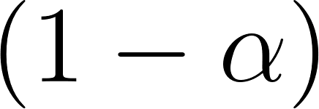](https://www.codecogs.com/eqnedit.php?latex=(1-%5Calpha)#0) implies that the probability of the maximum possible loss greater than the VaR is less than or equal to [](https://www.codecogs.com/eqnedit.php?latex=%5Calpha#0). For a portfolio manager with a long position (a short position), the risk measure VaR is related to downside risk (upside risk).

According to the VaR measure, the CoVaR measure (Adrian and Brunnermeier, 2016) is defined as follows. Given confidence level (1 - [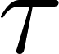](https://www.codecogs.com/eqnedit.php?latex=%5Ctau#0) ), the downside [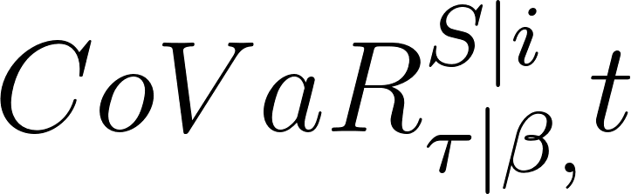](https://www.codecogs.com/eqnedit.php?latex=%7BCoVaR%7D_%7B%5Ctau%20%5Cmid%20%5Cbeta%2C%7D%5E%7BS%20%5Cmid%20i%7D%20t#0) and upside [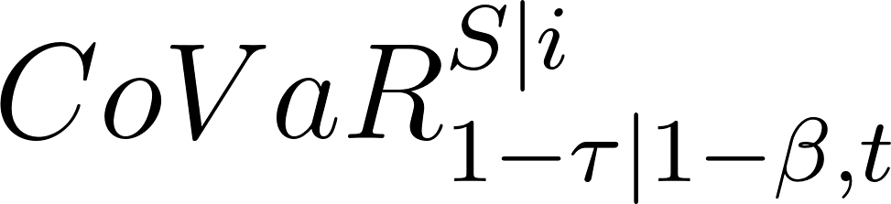](https://www.codecogs.com/eqnedit.php?latex=%7BCoVaR%7D_%7B1-%5Ctau%20%5Cmid%201-%5Cbeta%2C%20t%7D%5E%7BS%20%5Cmid%20i%7D#0) for the stock market [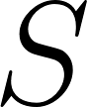](https://www.codecogs.com/eqnedit.php?latex=S#0), conditional on the downside [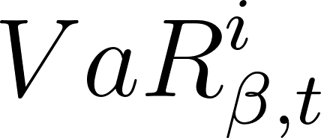](https://www.codecogs.com/eqnedit.php?latex=%7BVaR%7D_%7B%5Cbeta%2C%20t%7D%5E%7Bi%7D#0) and upside [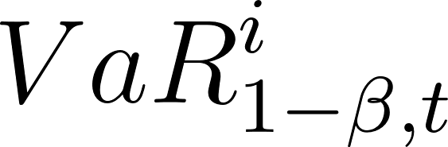](https://www.codecogs.com/eqnedit.php?latex=%7BVaR%7D_%7B1-%5Cbeta%2C%20t%7D%5E%7Bi%7D#0), for the returns of the oil market [](https://www.codecogs.com/eqnedit.php?latex=i#0) at the confidence level [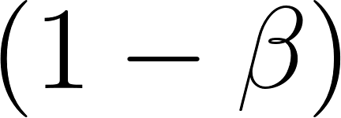](https://www.codecogs.com/eqnedit.php?latex=(1-%5Cbeta)#0) satisfy

[](https://www.codecogs.com/eqnedit.php?latex=%7BPr%7D%5Cleft(r_%7Bs%20t%7D%20%5Cleq%20%7BCoVaR%7D_%7B%5Ctau%20%5Cmid%20%5Cbeta%2C%20t%7D%5E%7BS%20%5Cmid%20i%7D%20%5Cmid%20r_%7Bi%20t%7D%3D%7BVaR%7D_%7B%5Cbeta%2C%20t%7D%5Ei%5Cright)%3D%7BPr%7D%5Cleft(r_%7Bs%20t%7D%20%5Cgeq%20%7BCoVaR%7D_%7B1-%5Ctau%20%5Cmid%201-%5Cbeta%2C%20t%7D%5E%7BS%20%5Cmid%20i%7D%20%5Cmid%20r_%7Bi%20t%7D%3D%7BVaR%7D_%7B1-%5Cbeta%2C%20t%7D%5Ei%5Cright)#0)

[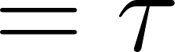](https://www.codecogs.com/eqnedit.php?latex=%3D%5Ctau#0)

Here, [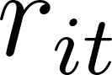](https://www.codecogs.com/eqnedit.php?latex=r_%7Bi%20t%7D#0) and [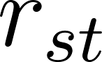](https://www.codecogs.com/eqnedit.php?latex=r_%7Bs%20t%7D#0) are the returns of oil markets [](https://www.codecogs.com/eqnedit.php?latex=i#0) and stock market [](https://www.codecogs.com/eqnedit.php?latex=S#0), respectively. Therefore, the risk spillover effect [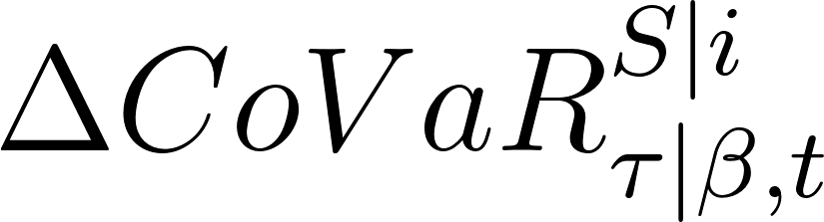](https://www.codecogs.com/eqnedit.php?latex=%5CDelta%20%7BCoVaR%7D_%7B%5Ctau%20%5Cmid%20%5Cbeta%2C%20t%7D%5E%7BS%20%5Cmid%20i%7D#0) of one oil market [](https://www.codecogs.com/eqnedit.php?latex=i#0) on the stock market [](https://www.codecogs.com/eqnedit.php?latex=S#0) at confidence level [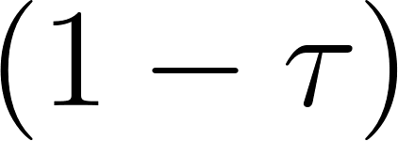](https://www.codecogs.com/eqnedit.php?latex=(1-%5Ctau)#0) can be defined as follows,

[](https://www.codecogs.com/eqnedit.php?latex=%20%5CDelta%20%7BCoVaR%7D_%7B%5Ctau%20%5Cmid%20%5Cbeta%2C%20t%7D%5E%7BS%20%5Cmid%20i%7D%3D%7BCoVaR%7D_%7B%5Ctau%20%5Cmid%20%5Cbeta%2C%20t%7D%5E%7BS%20%5Cmid%20i%7D-%7BCoVaR%7D_%7B%5Ctau%20%5Cmid%200.5%2C%20t%7D%5E%7BS%20%5Cmid%20i%7D%20#0)

where [](https://www.codecogs.com/eqnedit.php?latex=%7BCoVaR%7D_%7B%5Ctau%20%5Cmid%20%5Cbeta%2C%7D%5E%7BS%20%5Cmid%20i%7D%20t#0) and [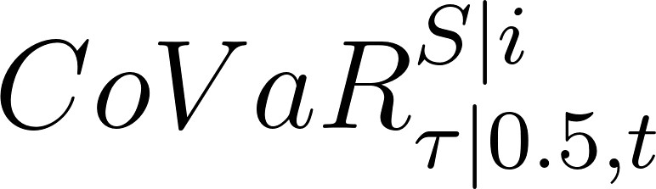](https://www.codecogs.com/eqnedit.php?latex=%7BCoVaR%7D_%7B%5Ctau%20%5Cmid%200.5%2C%20t%7D%5E%7BS%20%5Cmid%20i%7D#0) are the VaR of the stock market [](https://www.codecogs.com/eqnedit.php?latex=S#0) conditional on the oil market [](https://www.codecogs.com/eqnedit.php?latex=i#0) being in a distress state and a benchmark(normal) state, respectively.

The upside risk spillover effect can be calculated by the following equation:

[](https://www.codecogs.com/eqnedit.php?latex=%5CDelta%20%7BCoVaR%7D_%7B1-%5Ctau%20%5Cmid%201-%5Cbeta%2C%20t%7D%5E%7BS%20%5Cmid%20i%7D%3D%7BCoVaR%7D_%7B1-%5Ctau%20%5Cmid%201-%5Cbeta%2C%20t%7D%5E%7BS%20%5Cmid%20i%7D-%7BCoVaR%7D_%7B1-%5Ctau%20%5Cmid%200.5%2C%20t%5E%7Bt%7D%7D%5E%7BS%20%5Cmid%20i%7D#0)

The estimation of the downside risk spillover by the GARCH CQR-based DCoVaR model has been proposed by Tian and Ji (2022).

## *Marginal distribution model*

In this subsection, we introduce the ARMA-GARCH model, the most widely used approach to describe the properties of serial correlations, volatility clustering and conditional heteroskedasticity of financial returns. In general, the ARMA(p,q)-GARCH(m,s) model is constructed as follows:

The ARMA-GARCH model is the most widely used approach to describe the serial correlations, volatility clustering and conditional heteroskedasticity of returns. ARMA(p,q)-GARCH(m,s) model :

[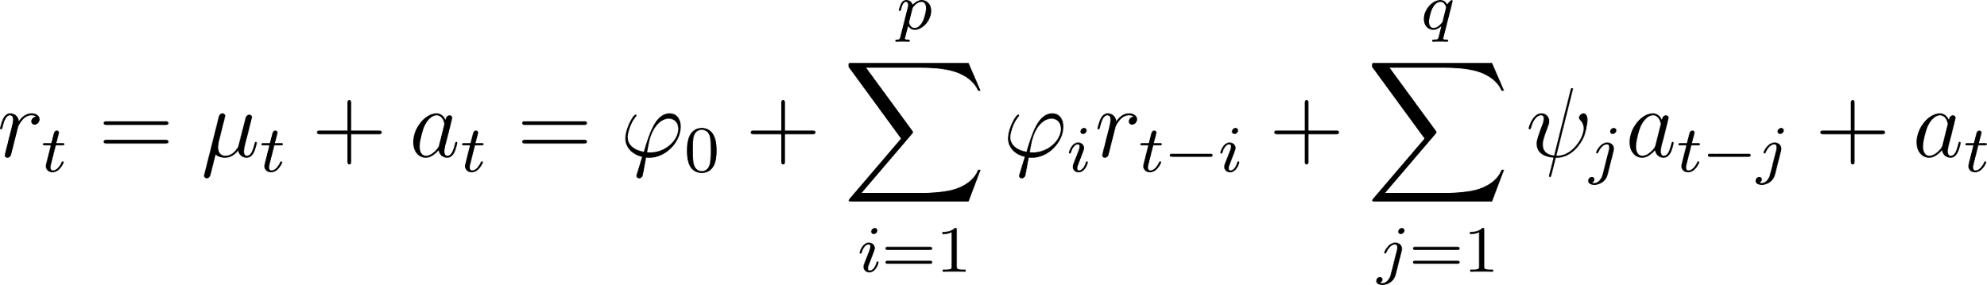](https://www.codecogs.com/eqnedit.php?latex=r_%7Bt%7D%3D%5Cmu_%7Bt%7D%2Ba_%7Bt%7D%3D%5Cvarphi_%7B0%7D%2B%5Csum_%7Bi%3D1%7D%5E%7Bp%7D%20%5Cvarphi_%7Bi%7D%20r_%7Bt-i%7D%2B%5Csum_%7Bj%3D1%7D%5E%7Bq%7D%20%5Cpsi_%7Bj%7D%20a_%7Bt-j%7D%2Ba_%7Bt%7D#0)

where [](https://www.codecogs.com/eqnedit.php?latex=p#0) and [](https://www.codecogs.com/eqnedit.php?latex=q#0) are nonnegative integers and [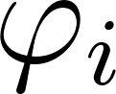](https://www.codecogs.com/eqnedit.php?latex=%5Cvarphi_%7Bi%7D#0) and [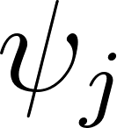](https://www.codecogs.com/eqnedit.php?latex=%5Cpsi_%7Bj%7D#0) are the autoregressive and moving average parameters, respectively. [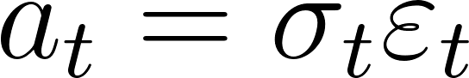](https://www.codecogs.com/eqnedit.php?latex=a_%7Bt%7D%3D%5Csigma_%7Bt%7D%20%5Cvarepsilon_%7Bt%7D#0), [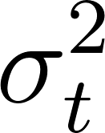](https://www.codecogs.com/eqnedit.php?latex=%5Csigma_%7Bt%7D%5E%7B2%7D#0) is the conditional variance that has dynamics as given by the GARCH model:

## 

where [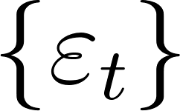](https://www.codecogs.com/eqnedit.php?latex=%5Cleft%5C%7B%5Cvarepsilon_%7Bt%7D%5Cright%5C%7D#0) is a sequence of i.i.d. random variables with mean 0 and variance 1[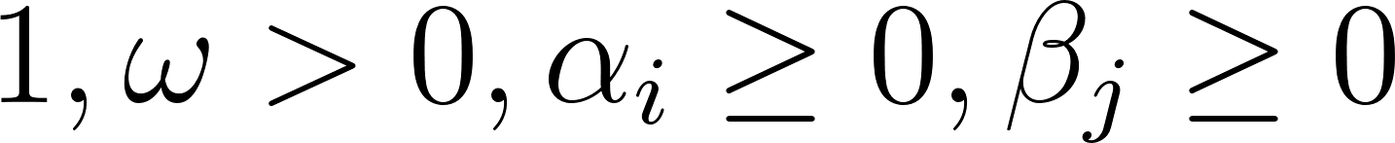](https://www.codecogs.com/eqnedit.php?latex=1%2C%20%5Comega%3E0%2C%20%5Calpha_%7Bi%7D%20%5Cgeq%200%2C%20%5Cbeta_%7Bj%7D%20%5Cgeq%200#0) and [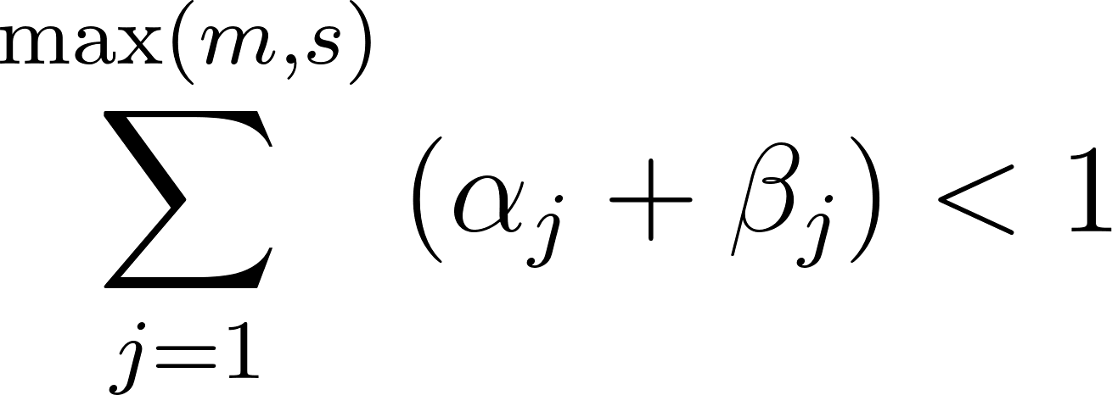](https://www.codecogs.com/eqnedit.php?latex=%5Csum_%7Bj%3D1%7D%5E%7B%5Cmax%20(m%2C%20s)%7D%5Cleft(%5Calpha_%7Bj%7D%2B%5Cbeta_%7Bj%7D%5Cright)%3C1#0).

To allow for asymmetric effects between positive and negative asset returns, the EGARCH model (Nelson, 1991) is proposed as follows:

[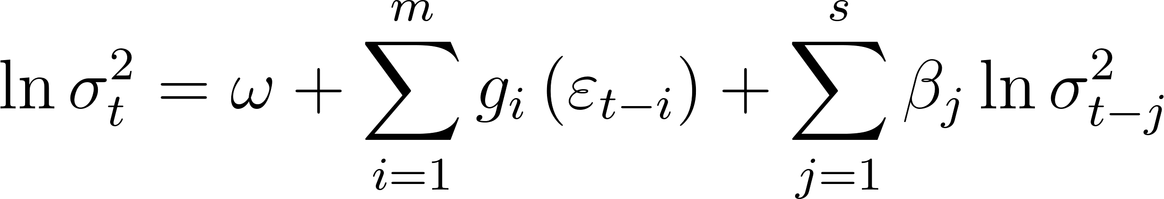](https://www.codecogs.com/eqnedit.php?latex=%5Cln%20%5Csigma_%7Bt%7D%5E%7B2%7D%3D%5Comega%2B%5Csum_%7Bi%3D1%7D%5E%7Bm%7D%20g_%7Bi%7D%5Cleft(%5Cvarepsilon_%7Bt-i%7D%5Cright)%2B%5Csum_%7Bj%3D1%7D%5E%7Bs%7D%20%5Cbeta_%7Bj%7D%20%5Cln%20%5Csigma_%7Bt-j%7D%5E%7B2%7D#0)

where [](https://www.codecogs.com/eqnedit.php?latex=%5Cleft%5C%7B%5Cvarepsilon_%7Bt%7D%5Cright%5C%7D#0) is a sequence of i.i.d. random variables with mean 0 and variance 1 , and [](https://www.codecogs.com/eqnedit.php?latex=g_%7Bi%7D%5Cleft(%5Cvarepsilon_%7Bt%7D%5Cright)%3D%5Cleft(%5Calpha_%7Bi%7D%20%5Cvarepsilon%2B%5Cgamma_%7Bi%7D%5Cleft(%5Cleft%7C%5Cvarepsilon_%7Bt%7D%5Cright%7C-E%5Cleft%7C%5Cvarepsilon_%7Bt%7D%5Cright%7C%5Cright)%5Cright)#0). Given distribution:

## ,

where [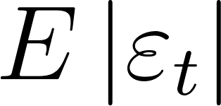](https://www.codecogs.com/eqnedit.php?latex=E%5Cleft%7C%5Cvarepsilon_%7Bt%7D%5Cright%7C#0) is the expected value of absolute standardized innovation [](https://www.codecogs.com/eqnedit.php?latex=%5Cvarepsilon_%7Bt%7D#0). The parameter [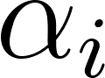](https://www.codecogs.com/eqnedit.php?latex=%5Calpha_%7Bi%7D#0) captures the sign effect and [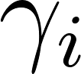](https://www.codecogs.com/eqnedit.php?latex=%5Cgamma_%7Bi%7D#0) the magnitude effect, which covers the asymmetry of the volatility for positive and negative returns which is commonly attributed to the leverage effect of equity returns.

## The standardized residuals generally exhibit the characteristics of both kurtosis and skewness, which follow a standardized skew Student's distribution (SSST) (Tsay, 2012). Let be the SSST distribution, and its PDF (probability density function) is

## 

where [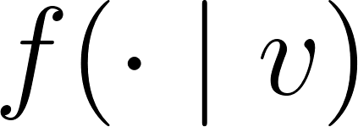](https://www.codecogs.com/eqnedit.php?latex=f(%5Ccdot%20%5Cmid%20v)#0) is the PDF of the standardized Student's [](https://www.codecogs.com/eqnedit.php?latex=t#0) distribution (SST):

[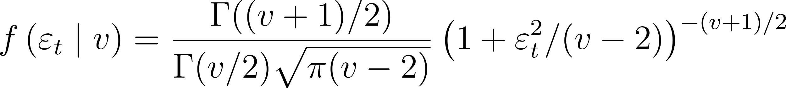](https://www.codecogs.com/eqnedit.php?latex=f%5Cleft(%5Cvarepsilon_%7Bt%7D%20%5Cmid%20v%5Cright)%3D%5Cfrac%7B%5CGamma((v%2B1)%20%2F%202)%7D%7B%5CGamma(v%20%2F%202)%20%5Csqrt%7B%5Cpi(v-2)%7D%7D%5Cleft(1%2B%5Cvarepsilon_%7Bt%7D%5E%7B2%7D%20%2F(v-2)%5Cright)%5E%7B-(v%2B1)%20%2F%202%7D#0)

where [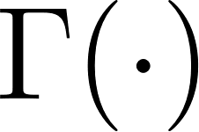](https://www.codecogs.com/eqnedit.php?latex=%5CGamma(%5Ccdot)#0) is the gamma function and [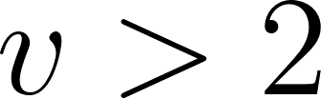](https://www.codecogs.com/eqnedit.php?latex=v%3E2#0) is the degree of freedom. [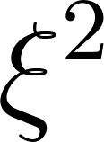](https://www.codecogs.com/eqnedit.php?latex=%5Cxi%5E%7B2%7D#0) is equal to the ratio of probability masses above and below the mode of the distribution; hence, [](https://www.codecogs.com/eqnedit.php?latex=%5Cxi#0) is the skewness parameter, [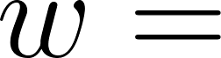](https://www.codecogs.com/eqnedit.php?latex=w%3D#0) [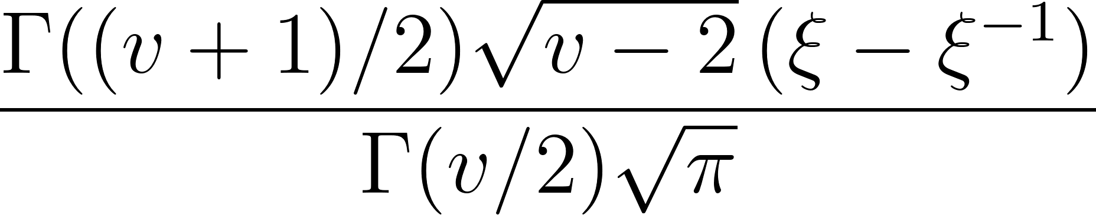](https://www.codecogs.com/eqnedit.php?latex=%5Cfrac%7B%5CGamma((v%2B1)%20%2F%202)%20%5Csqrt%7Bv-2%7D%5Cleft(%5Cxi-%5Cxi%5E%7B-1%7D%5Cright)%7D%7B%5CGamma(v%20%2F%202)%20%5Csqrt%7B%5Cpi%7D%7D#0), and [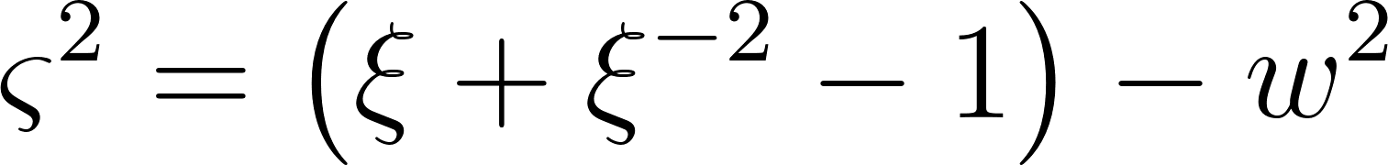](https://www.codecogs.com/eqnedit.php?latex=%5Cvarsigma%5E%7B2%7D%3D%5Cleft(%5Cxi%2B%5Cxi%5E%7B-2%7D-1%5Cright)-w%5E%7B2%7D#0).

Let the cumulative distribution functions (CDFs) be [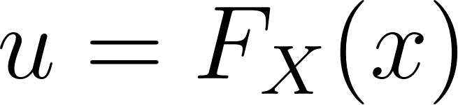](https://www.codecogs.com/eqnedit.php?latex=u%3DF_%7BX%7D(x)#0) and [](https://www.codecogs.com/eqnedit.php?latex=v#0) [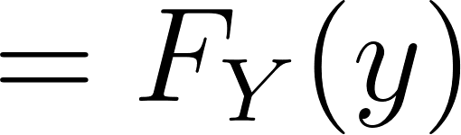](https://www.codecogs.com/eqnedit.php?latex=%3DF_%7BY%7D(y)#0), respectively. They can be connected by the copula function [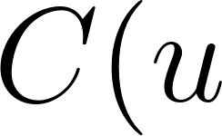](https://www.codecogs.com/eqnedit.php?latex=C(u#0), [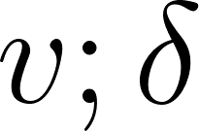](https://www.codecogs.com/eqnedit.php?latex=v%20%3B%20%5Cdelta#0) ) with parameter [](https://www.codecogs.com/eqnedit.php?latex=%5Cdelta#0) and we can get the joint distribution function [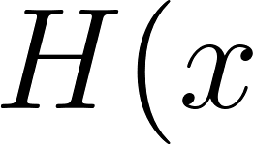](https://www.codecogs.com/eqnedit.php?latex=H(x#0), [](https://www.codecogs.com/eqnedit.php?latex=y)%3DC%5Cleft(F_%7BX%7D(x)%2C%20F_%7BY%7D(y)%20%3B%20%5Cdelta%5Cright)#0) (Sklar, 1959). The bivariate one-parameter copula families given in Joe (1997) include B1 (Normal copula), B2 (Plackett copula), B3 (Frank copula), B4 (Clayton copula), B5 (Joe copula), B6 (Gumbel copula), B7 (Galambos copula), B8 (Hüsler-Reiss copula), B9 (Raftery copula), B10 (Morgenstern copula), B11 and B12. However, B1, [](https://www.codecogs.com/eqnedit.php?latex=%5Cmathrm%7BB%7D%202#0), B3 and B10 cannot capture the property of asymmetric tail dependence, moreover the function of B9, B11 and B12 are complicated and non-differentiable. Among the other five copulas, the Clayton copula can describe downside tail dependence structure, and the Joe copula, Gumbel copula, Galambos copula and Hüsler-Reiss copula can capture upside tail dependence structure. Therefore, these five copulas and their 180-degree rotated forms (Joe,1997; Nelsen, 2006) are selected in this study to capture the nonlinearity and asymmetry of the tail dependence structure, which are shown in Table 1.

## Based on the definition of conditional CDF H(y|x), we have

[](https://www.codecogs.com/eqnedit.php?latex=%5Ctau%3DH(y%20%5Cmid%20x)%3D%7BPr%7D(Y%20%5Cleq%20y%20%5Cmid%20X%3Dx)%3D%5Clim%20_%7B%5CDelta%20x%20%5Crightarrow%200%7D%20%7BPr%7D(Y%20%5Cleq%20y%20%5Cmid%20x%20%5Cleq%20X%20%5Cleq%20x%2B%5CDelta%20x)%5C%5C#0)[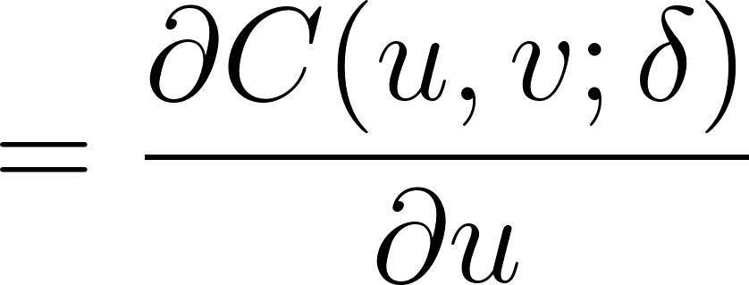](https://www.codecogs.com/eqnedit.php?latex=%3D%5Cfrac%7B%5Cpartial%20C(u%2C%20v%20%3B%20%5Cdelta)%7D%7B%5Cpartial%20u%7D#0)

where [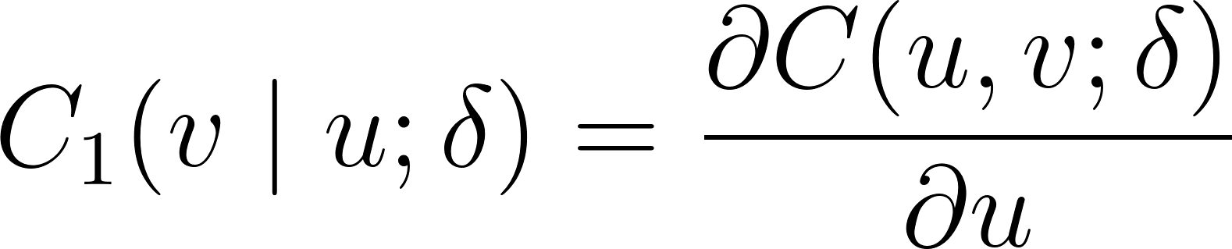](https://www.codecogs.com/eqnedit.php?latex=C_%7B1%7D(v%20%5Cmid%20u%20%3B%20%5Cdelta)%3D%5Cfrac%7B%5Cpartial%20C(u%2C%20v%20%3B%20%5Cdelta)%7D%7B%5Cpartial%20u%7D#0) is conditional copula. The function values are shown in Table 2. Fixing the conditional probability of [](https://www.codecogs.com/eqnedit.php?latex=Y#0) given [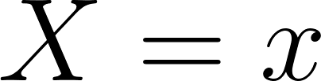](https://www.codecogs.com/eqnedit.php?latex=X%3Dx#0) at quantile [](https://www.codecogs.com/eqnedit.php?latex=%5Ctau#0); we can get

[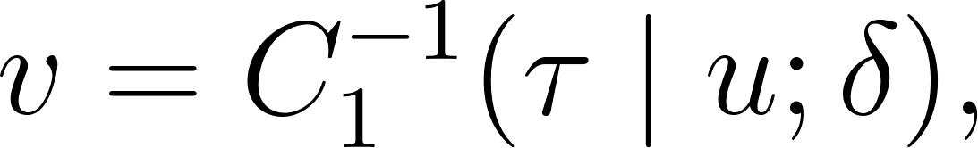](https://www.codecogs.com/eqnedit.php?latex=v%3DC_%7B1%7D%5E%7B-1%7D(%5Ctau%20%5Cmid%20u%20%3B%20%5Cdelta)%2C#0)

by solving [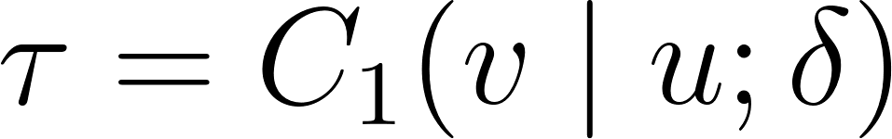](https://www.codecogs.com/eqnedit.php?latex=%5Ctau%3DC_%7B1%7D(v%20%5Cmid%20u%20%3B%20%5Cdelta)#0) for [](https://www.codecogs.com/eqnedit.php?latex=v#0). Eq. (7) presents the [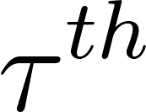](https://www.codecogs.com/eqnedit.php?latex=%5Ctau%5E%7B%20%7Bth%7D%7D#0) copula quantile curve for [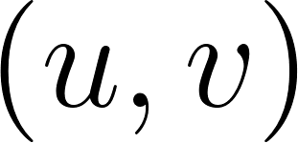](https://www.codecogs.com/eqnedit.php?latex=(u%2C%20v)#0).

Considering [](https://www.codecogs.com/eqnedit.php?latex=u%3DF_%7BX%7D(x)#0) and [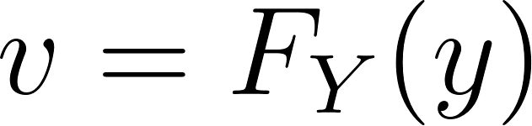](https://www.codecogs.com/eqnedit.php?latex=v%3DF_%7BY%7D(y)#0), Eq. can be rewritten as

[](https://www.codecogs.com/eqnedit.php?latex=F_%7BY%7D(y)%3DC_%7B1%7D%5E%7B-1%7D%5Cleft(%5Ctau%20%5Cmid%20F_%7BX%7D(x)%20%3B%20%5Cdelta%5Cright).#0)

Therefore, we can get the CQR function for [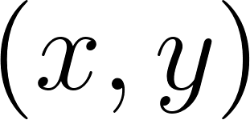](https://www.codecogs.com/eqnedit.php?latex=(x%2C%20y)#0) at quantile [](https://www.codecogs.com/eqnedit.php?latex=%5Ctau#0) as follows

[](https://www.codecogs.com/eqnedit.php?latex=y%3DF_%7BY%7D%5E%7B-1%7D%5Cleft(C_%7B1%7D%5E%7B-1%7D%5Cleft(%5Ctau%20%5Cmid%20F_%7BX%7D(x)%20%3B%20%5Cdelta%5Cright)%5Cright)%2C#0)

## 

#### *Table 1: Copula models.*

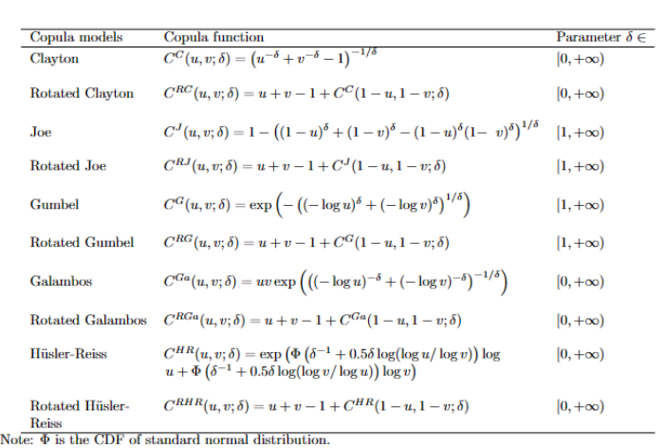

Note: 𝛟 is the CDF of standard normal distribution.

where [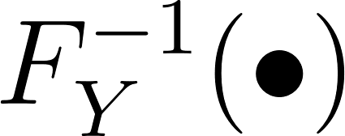](https://www.codecogs.com/eqnedit.php?latex=F_%7BY%7D%5E%7B-1%7D(%5Cbullet)#0) is the quantile function.

Similarly, based on the definition of upside CoVaR, for the [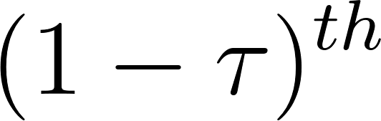](https://www.codecogs.com/eqnedit.php?latex=(1-%5Ctau)%5E%7B%20%7Bth%20%7D%7D#0) conditional quantile of [](https://www.codecogs.com/eqnedit.php?latex=Y#0) given [](https://www.codecogs.com/eqnedit.php?latex=X%3Dx#0), we have

## 

[](https://www.codecogs.com/eqnedit.php?latex=%5Ctau%3D%7BPr%7D(Y%20%5Cgeq%20y%20%5Cmid%20X%3Dx)%3D1-%7BPr%7D(Y%20%5Cleq%20y%20%5Cmid%20X%3Dx)%3D1-C_%7B1%7D(v%20%5Cmid%20u%20%3B%20%5Cdelta)%2C#0)

Solving [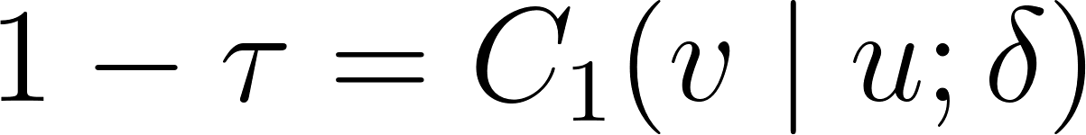](https://www.codecogs.com/eqnedit.php?latex=1-%5Ctau%3DC_%7B1%7D(v%20%5Cmid%20u%20%3B%20%5Cdelta)#0) for [](https://www.codecogs.com/eqnedit.php?latex=v#0) yields the [](https://www.codecogs.com/eqnedit.php?latex=(1-%5Ctau)%5E%7Bt%20h%7D#0) CQR curve for [](https://www.codecogs.com/eqnedit.php?latex=(u%2C%20v)#0) as the following equation:

[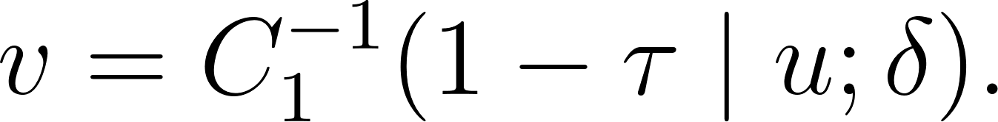](https://www.codecogs.com/eqnedit.php?latex=%20%20%20%20v%3DC_%7B1%7D%5E%7B-1%7D(1-%5Ctau%20%5Cmid%20u%20%3B%20%5Cdelta).#0)

Therefore, the CQR function for [](https://www.codecogs.com/eqnedit.php?latex=(x%2C%20y)#0) at quantile [](https://www.codecogs.com/eqnedit.php?latex=(1-%5Ctau)#0) is

[](https://www.codecogs.com/eqnedit.php?latex=y%3DF_%7BY%7D%5E%7B-1%7D%5Cleft(C_%7B1%7D%5E%7B-1%7D%5Cleft(1-%5Ctau%20%5Cmid%20F_%7BX%7D(x)%20%3B%20%5Cdelta%5Cright)%5Cright).#0)

#### *Table 2 : Conditional distributions of copula models.*

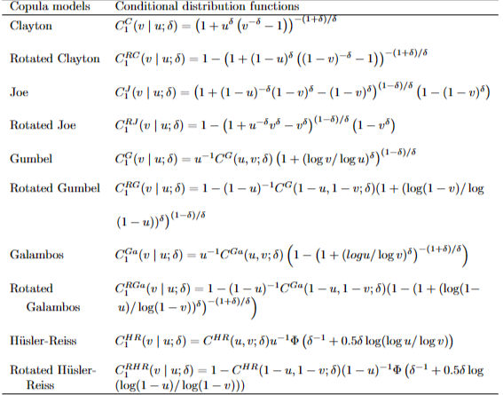

*Note: See notes for Table 1.*

Among all the above-mentioned copulas presented in Tables 1 and 2, *Clayton copula, rotated copulas of Joe, Gumbel, Galambos and H ̈uslerReiss* can describe downside tail dependence and upside tail independence. On the other hand, *the rotated Clayton copula, Joe copula, Gumbel copula, Galambos copula and H ̈usler-Reiss copula* can capture upside tail dependence and downside tail independence. Thus, the corresponding CQR function could properly describe the lower or upper tail dependence between random variables (X, Y ) or (U, V ). To illustrate this desirable property, we generate 2000 random values of (U, V ) for different copula with different parameters δ, and the marginal distributions of X and Y follow the SSST distribution with different parameters. We plot the CQR curves for ten copula families in Appendix A displaying different tail dependence behaviour.

## *GARCH CQR-based UCoVaR model*

[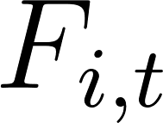](https://www.codecogs.com/eqnedit.php?latex=F_%7Bi%2C%20t%7D#0) and [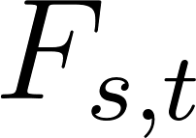](https://www.codecogs.com/eqnedit.php?latex=F_%7Bs%2C%20t%7D#0) denote the CDFs of [](https://www.codecogs.com/eqnedit.php?latex=r_%7Bi%20t%7D#0) and [](https://www.codecogs.com/eqnedit.php?latex=r_%7Bs%20t%7D#0), returns of oil market [](https://www.codecogs.com/eqnedit.php?latex=i#0) and stock market [](https://www.codecogs.com/eqnedit.php?latex=S#0), respectively. Thus, according to the definition of upside CoVaR and Eq. (10), we have

[](https://www.codecogs.com/eqnedit.php?latex=%5Ctau%3D%7BPr%7D%5Cleft(r_%7Bs%20t%7D%20%5Cgeq%20%7BCoVaR%7D_%7B1-%5Ctau%20%5Cmid%201-%5Cbeta%2C%20t%7D%5E%7BS%20%5Cmid%20i%7D%20%5Cmid%20r_%7Bi%20t%7D%3D%7BVaR%7D_%7B1-%5Cbeta%2C%20t%7D%5E%7Bi%7D%5Cright)#0)

[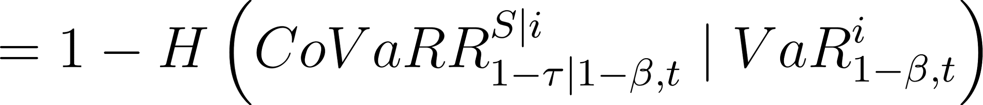](https://www.codecogs.com/eqnedit.php?latex=%3D1-H%5Cleft(%7BCoVaR%7D%20R_%7B1-%5Ctau%20%5Cmid%201-%5Cbeta%2C%20t%7D%5E%7BS%20%5Cmid%20i%7D%20%5Cmid%20%7BVaR%7D_%7B1-%5Cbeta%2C%20t%7D%5E%7Bi%7D%5Cright)#0)

[](https://www.codecogs.com/eqnedit.php?latex=%3D1-C_%7B1%7D%5Cleft(F_%7Bs%2C%20t%7D%5Cleft(%7BCoVaR%7D_%7B1-%5Ctau%20%5Cmid%201-%5Cbeta%2C%20t%7D%5E%7BS%20%5Cmid%20i%7D%5Cright)%20%5Cmid%20F_%7Bi%2C%20t%7D%5Cleft(%7BVaR%7D_%7B1-%5Cbeta%2C%20t%7D%5E%7Bi%7D%5Cright)%20%3B%20%5Cdelta%5Cright)#0)

[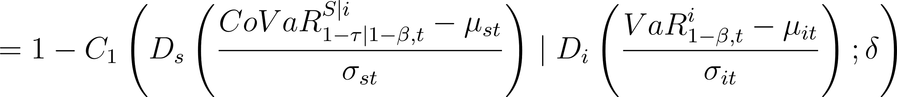](https://www.codecogs.com/eqnedit.php?latex=%3D1-C_%7B1%7D%5Cleft(D_%7Bs%7D%5Cleft(%5Cfrac%7B%7BCoVaR%7D_%7B1-%5Ctau%20%5Cmid%201-%5Cbeta%2C%20t%7D%5E%7BS%20%5Cmid%20i%7D-%5Cmu_%7Bs%20t%7D%7D%7B%5Csigma_%7Bs%20t%7D%7D%5Cright)%20%5Cmid%20D_%7Bi%7D%5Cleft(%5Cfrac%7B%7BVaR%7D_%7B1-%5Cbeta%2C%20t%7D%5E%7Bi%7D-%5Cmu_%7Bi%20t%7D%7D%7B%5Csigma_%7Bi%20t%7D%7D%5Cright)%20%3B%20%5Cdelta%5Cright)#0)

or

[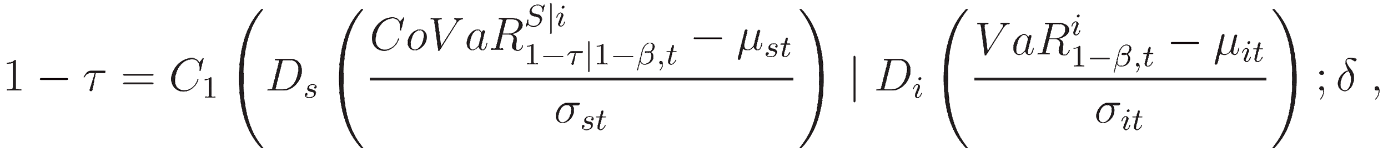](http://www.sciweavers.org/tex2img.php?bc=Transparent&fc=Black&im=jpg&fs=100&ff=modern&edit=0&eq=1-%5Ctau%3DC_%7B1%7D%5Cleft(D_%7Bs%7D%5Cleft(%5Cfrac%7B%7BCoVaR%7D_%7B1-%5Ctau%20%5Cmid%201-%5Cbeta%2C%20t%7D%5E%7BS%20%5Cmid%20i%7D-%5Cmu_%7Bs%20t%7D%7D%7B%5Csigma_%7Bs%20t%7D%7D%5Cright)%20%5Cmid%20D_%7Bi%7D%5Cleft(%5Cfrac%7B%7BVaR%7D_%7B1-%5Cbeta%2C%20t%7D%5E%7Bi%7D-%5Cmu_%7Bi%20t%7D%7D%7B%5Csigma_%7Bi%20t%7D%7D%5Cright)%20%3B%20%5Cdelta%5Cright%2C#0)

where [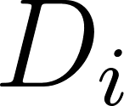](https://www.codecogs.com/eqnedit.php?latex=D_%7Bi%7D#0) and [](https://www.codecogs.com/eqnedit.php?latex=D_%7Bs%7D#0) denote the CDFs of [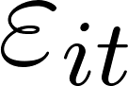](https://www.codecogs.com/eqnedit.php?latex=%5Cvarepsilon_%7Bi%20t%7D#0) and [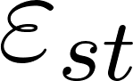](https://www.codecogs.com/eqnedit.php?latex=%5Cvarepsilon_%7Bs%20t%7D#0), the standardized residuals of [](https://www.codecogs.com/eqnedit.php?latex=r_%7Bi%20t%7D#0) and [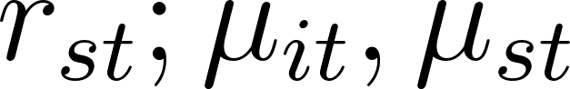](https://www.codecogs.com/eqnedit.php?latex=r_%7Bs%20t%7D%20%3B%20%5Cmu_%7Bi%20t%7D%2C%20%5Cmu_%7Bs%20t%7D#0) and [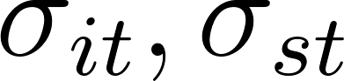](https://www.codecogs.com/eqnedit.php?latex=%5Csigma_%7Bi%20t%7D%2C%20%5Csigma_%7Bs%20t%7D#0) are the conditional mean and standard deviation of the returns of oil market [](https://www.codecogs.com/eqnedit.php?latex=i#0) and stock market [](https://www.codecogs.com/eqnedit.php?latex=S#0), estimated by Eqs. (3), (4) or (5).

## According to Eqs. (11) and (12), Eq. (14) is equivalent to

## 

Therefore, the upside CoVaR can be estimated by

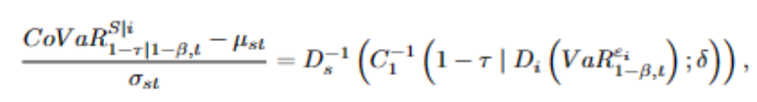

or



where [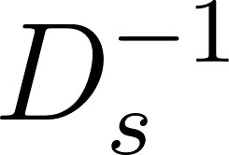](https://www.codecogs.com/eqnedit.php?latex=D_%7Bs%7D%5E%7B-1%7D#0) is the quantile function of [](https://www.codecogs.com/eqnedit.php?latex=%5Cvarepsilon_%7Bs%20t%7D#0). Following Tian and Ji (2022), we can estimate the parameter [](https://www.codecogs.com/eqnedit.php?latex=%5Cdelta#0) in Eq. (17) by interior point algorithm for nonlinear quantile regression model (Koenker and Park, 1996) at the [](https://www.codecogs.com/eqnedit.php?latex=(1-%5Ctau)%5E%7Bt%20h%7D#0) quantile:

[](https://www.codecogs.com/eqnedit.php?latex=Q_%7B1-%5Ctau%7D%5Cleft(%5Cvarepsilon_%7Bs%20t%7D%20%5Cmid%20%5Cvarepsilon_%7Bi%20t%7D%5Cright)%3D%5Ctheta_%7B1-%5Ctau%7D%2B%5Ceta_%7B1-%5Ctau%7D%20D_%7Bs%7D%5E%7B-1%7D%5Cleft(C_%7B1%7D%5E%7B-1%7D%5Cleft(1-%5Ctau%20%5Cmid%20D_%7Bi%7D%5Cleft(%5Cvarepsilon_%7Bi%20t%7D%5Cright)%20%3B%20%5Cdelta_%7B1-%5Ctau%7D%5Cright)%5Cright)%2C#0)

based on [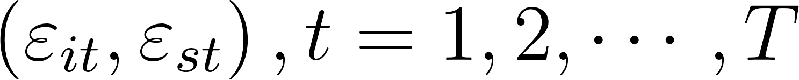](https://www.codecogs.com/eqnedit.php?latex=%5Cleft(%5Cvarepsilon_%7Bi%20t%7D%2C%20%5Cvarepsilon_%7Bs%20t%7D%5Cright)%2C%20t%3D1%2C2%2C%20%5Ccdots%2C%20T#0), where [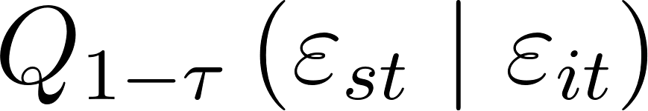](https://www.codecogs.com/eqnedit.php?latex=Q_%7B1-%5Ctau%7D%5Cleft(%5Cvarepsilon_%7Bs%20t%7D%20%5Cmid%20%5Cvarepsilon_%7Bi%20t%7D%5Cright)#0) is the [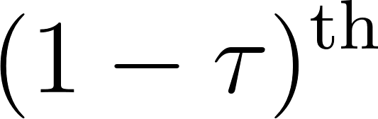](https://www.codecogs.com/eqnedit.php?latex=(1-%5Ctau)%5E%7B%5Cmathrm%7Bth%7D%7D#0) conditional quantile of [](https://www.codecogs.com/eqnedit.php?latex=%5Cvarepsilon_%7Bs%20t%7D#0) given [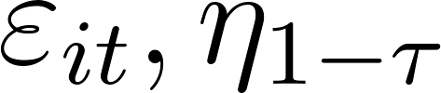](https://www.codecogs.com/eqnedit.php?latex=%5Cvarepsilon_%7Bi%20t%7D%2C%20%5Ceta_%7B1-%5Ctau%7D#0) is the zooming parameter and [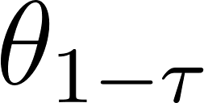](https://www.codecogs.com/eqnedit.php?latex=%5Ctheta_%7B1-%5Ctau%7D#0) is the panning parameter.

Therefore, given confidence levels [](https://www.codecogs.com/eqnedit.php?latex=(1-%5Ctau)#0) and [](https://www.codecogs.com/eqnedit.php?latex=(1-%5Cbeta)#0), the upside CoVaR of the stock market [](https://www.codecogs.com/eqnedit.php?latex=S#0) conditional on the upside value at risk of the oil market [](https://www.codecogs.com/eqnedit.php?latex=i#0) being [](https://www.codecogs.com/eqnedit.php?latex=%7BVaR%7D_%7B1-%5Cbeta%2C%20t%7D%5E%7Bi%7D#0) can be obtained as follows:

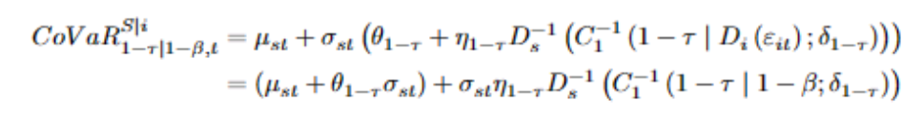

Eq. (19) is the GARCH CQR-based UCoVaR model. Meanwhile, the follow- ing equation is the GARCH CQR-based DCoVaR model (Tian and Ji, 2022):



In particular, the upside and downside CoVaRs of the stock market S conditional on oil market i being in its benchmark state (β = 0.5) can also be calculated by Eqs. (19) and (20), respectively. Therefore, the downward and upward risk spillover effects are determined by



and



It is worth noting that when applying Eq. (19) to calculate the upside risk spillover effect, the copula function should be selected from rotated Clayton copula, Gumbel copula, Joe copula, H ̈usler-Reiss copula and Galambos copula, which can describe the lower tail independence and upper tail dependence between financial returns. Meanwhile, regarding the downside risk spillovers, the copula function in Eq. (20) is the optimal one of Clayton copula, rotated copulas of Gumbel, Joe, H ̈uslerReiss and Galambos, which can capture the upper tail independence and lower tail dependence. In addition, the GARCH CQR model has the following two advantages over other similar approaches, first, it can describe the nonlinearity of the downside and upside tail dependence structure between the oil and the stock market returns at different risk levels; second, it can accurately capture the properties of serial correlation and volatility clustering of the financial asset returns.

## 

## ***DATA***

Examining risk spillovers from the Brent Crude oil market to six nations' stock markets - Brazil, China, India, Indonesia, South Korea and Mexico: we selected daily data of MSCI indices. These were chosen as a representation for the stock market indices–from January 1st 2001 through December 31st 2022 (a total of 5739 observations). In addition to this dataset acquisition—Bloomberg terminal provided us with Brent Crude oil prices' collection; however, it was only possible to gather data for Kuwait starting in 2005.

We initially graphed the basic daily closing prices of the index against each country's daily oil market closure. This step illuminated long-term trends in MSCI price indices and Brent Crude oil prices over our analyzed period; moreover, it became evident that significant fluctuations among all eight price indices are relatively similar. Figure 2 typically illustrates a drastic downward trend of the eleven price indices following severe risk events such as the European debt crisis, global financial crisis, COVID-19 pandemic and Russia-Ukraine conflict; this implies a notable correlation between these events and substantial market downturns.

We then graphed each index's log returns alongside those of the Brent Crude oil market. A similar volatility clustering occurs about this specific period, yet responses to the shocks differ across diverse financial markets (see Figure 3).

Each country's oil and index returns exhibit a nonlinear relationship in the scatter plots, specifically within their upper and lower tails; this implies the necessity of employing a nonlinear model to scrutinize risk spillover effects from the oil market onto stock markets.

Finally, we employed descriptive statistics for a numerical analysis of the trend. The table incorporates mean, maxima and minima, median; skewness, standard deviation - also known as volatility - and kurtosis. Additionally—by using certain test statistics—we will check the presence of normality, Autocorrelation, ARCH and GARCH (as shown in Table 3).

RESULTS & DISCUSSION

*5.1. Estimates of the marginal distribution*

To capture the distribution properties of heavy tails, skewness, autocorrelation and volatility clustering, marginal distribution for oil and stock market returns are built with the standard normal, SST and SSST distribution on the ARMA-GARCH family models. Table 4 shows the AIC (Akaike information criterion) and LLF (log-likelihood) for model selection. Based on the values of AIC and LLF, the ARMA(1,1)-EGARCH(1,1) model with SSST innovation fits the financial returns best. Table 5 shows the estimated parameters, ARCH and Ljung-Box tests for model adequacy.

Ljung-Box test applied to the standardize residuals (and the square of the standardized residuals) of the ARMA(1,1)-EGARCH(1,1) model with SSST innovation does not reject the null hypothesis of autocorrelations at lag 20 at the 5% significance level.

The Engle’s LM test suggests the absence of ARCH effects in all the return series at the 5% significance level.The estimates of parameters and the standard deviations show that the ARMA(1,1)-EGARCH(1,1) model is adequate. Furthermore, the parameter estimates of the SSST distribution confirm that the standardized residuals do not follow the normal distribution, which is consistent with the negative values for skewness and high values for the kurtosis statistic reported in Table 3.

Fig. 1 presents the long term trends of the MSCI price indices and the Brent oil price over the period analyzed. Note that the huge fluctuations of eleven price indices are quite similar. Specifically, the extreme risk events, such as the global financial crisis, the European debt crisis and the COVID-19 pandemic, usually resulted in an extreme downward trend of the eleven price indices.

Fig. 2 plots the returns of these price indices which are given as rt = 100 × (lnPt − ln Pt− 1). Obviously, there is also a similar volatility clustering along with the occurrence of the global financial crisis, the European debt crisis and the COVID-19 pandemic. However, the reactions of different financial markets to extreme shocks have been heterogeneous over time. These characteristics provide an opportunity to explore risk spillovers from oil market to the stock markets.

Table 3 reports the descriptive statistics of these financial market returns. The means and medians of returns are close to zero, and high standard deviations of the returns imply large dispersion in volatility. All financial returns have negative skewness values and high values for the kurtosis statistic, consistent with the properties of sharp peaks, fat tails and being skewed for the return distributions. At the same time, the normality of stock returns is rejected by Jarque-Bera statistics. Furthermore, the results of Ljung-Box test reject the null hypothesis of autocorrelations at lag 20 at the 5% significance level; and Engle’s Lagrange multiplier (LM) test reveals strong evidence of ARCH effects in all the financial return series at the 5% significance level. *Fig. 3. Scatter plots of returns between the oil market and the stock markets.*

Finally, the correlation coefficients between returns of Brent crude oil market and stock markets are positive and significantly different from zero, which is in line with the scatter plots presented in Fig. 3. The scatter plots showing a nonlinear relationship in the upper and lower tails indicates that we should use the nonlinear model to study the risk spillover effect from oil market to stock markets.

China India

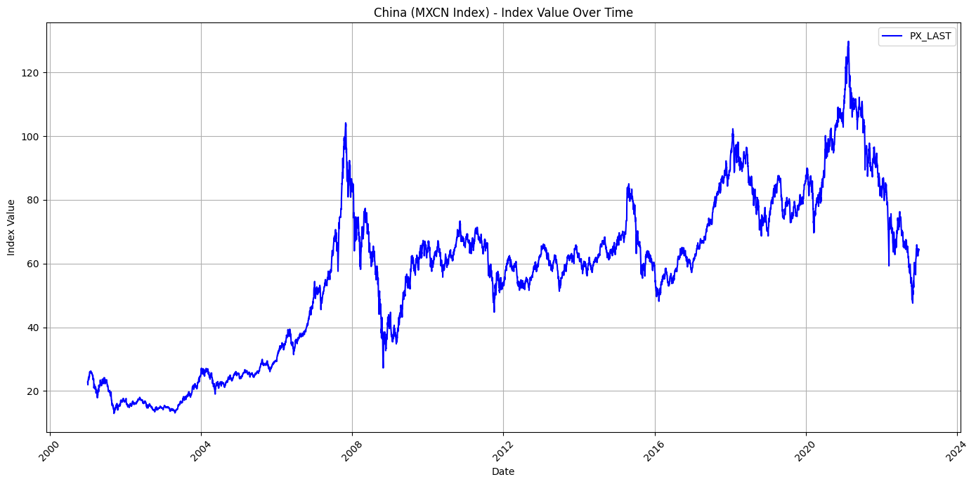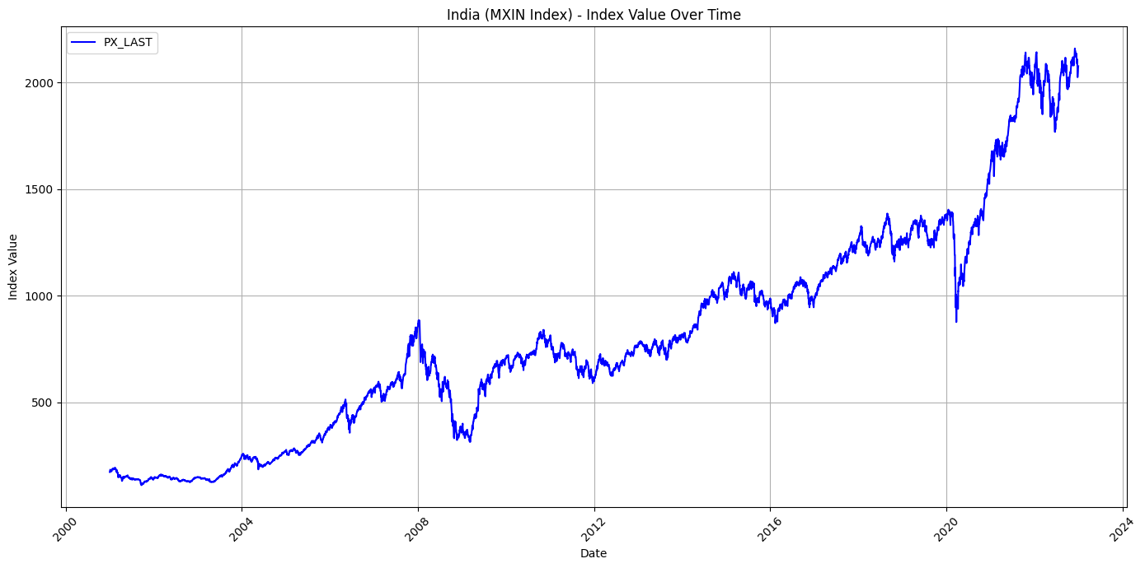

Indonesia Kuwait

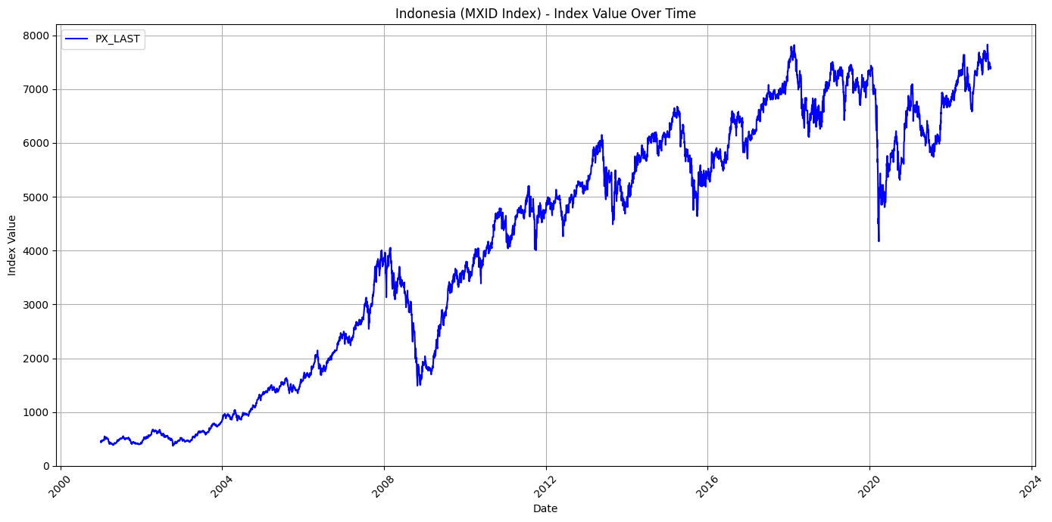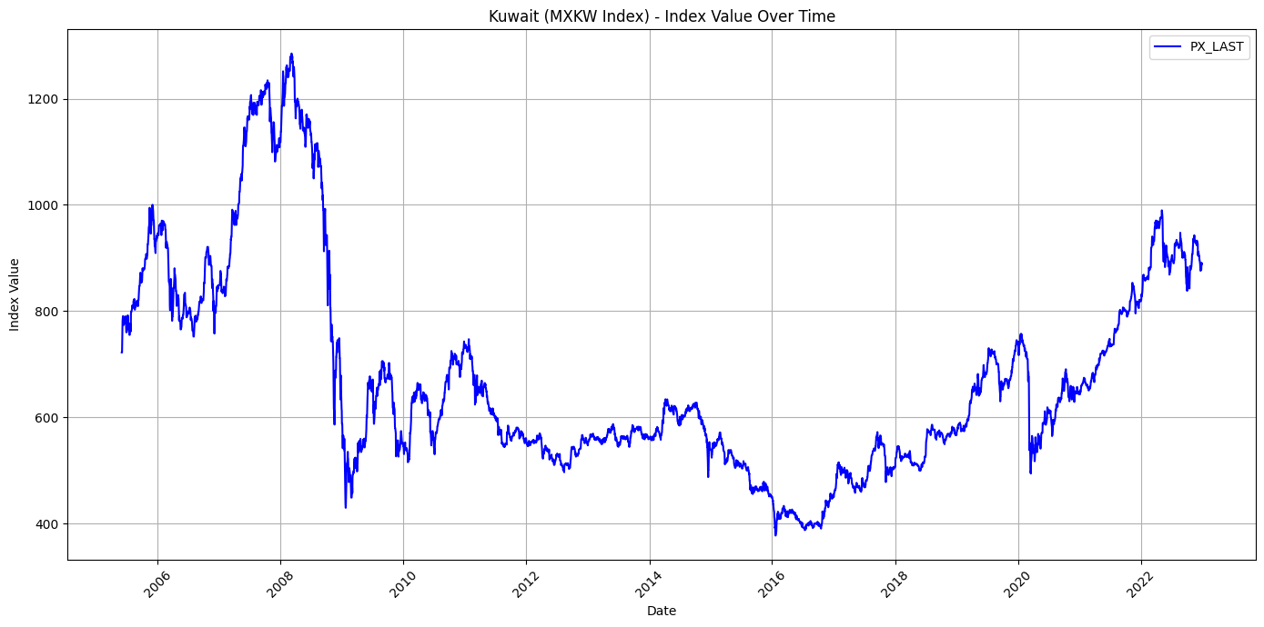

*Fig. 1. MSCI indices of different financial markets*

Mexico Brazil

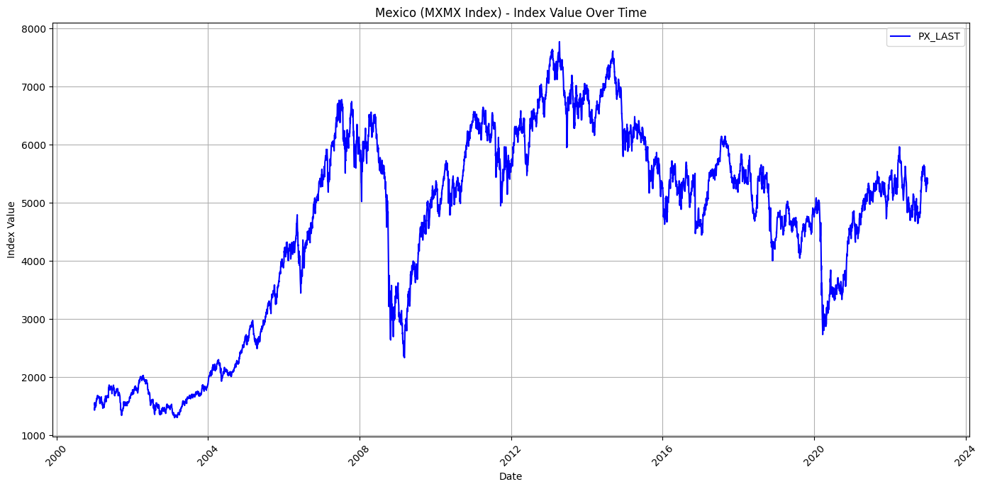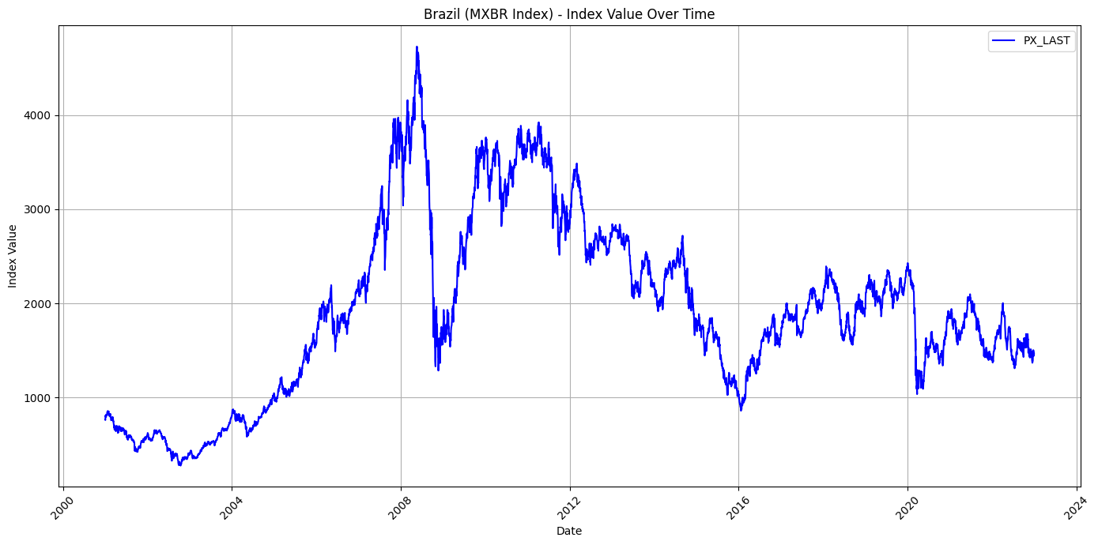

South Korea

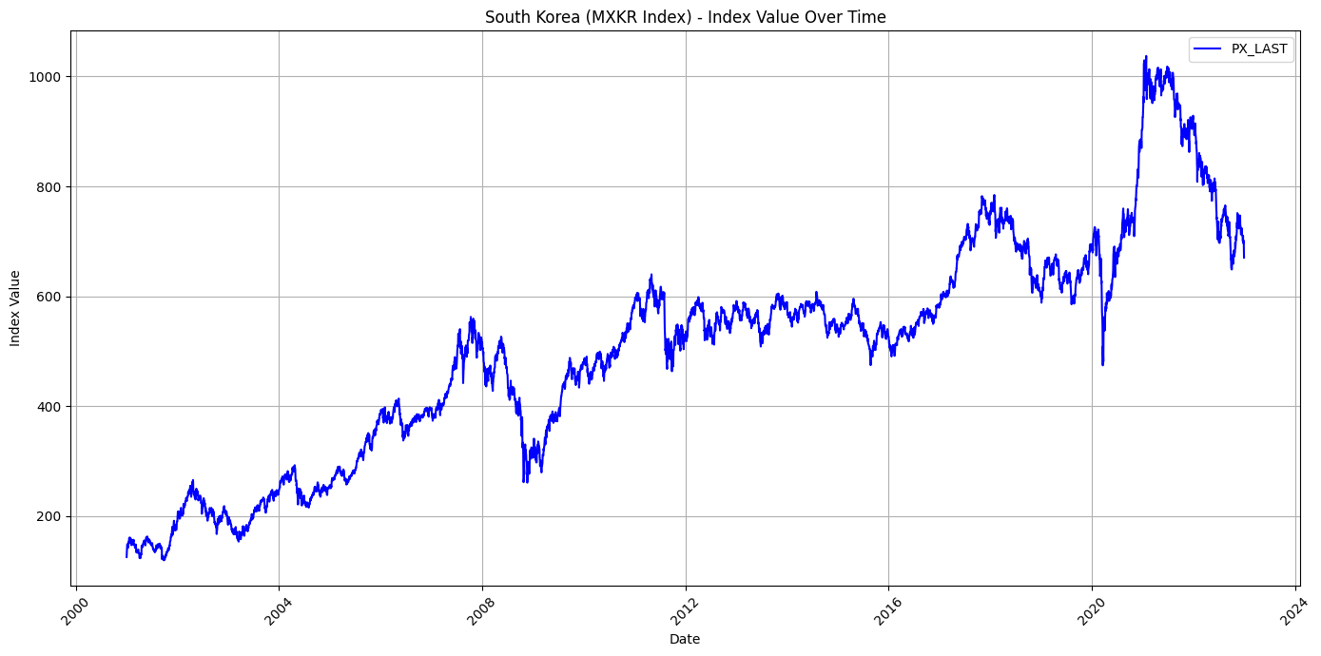

Brent Oil

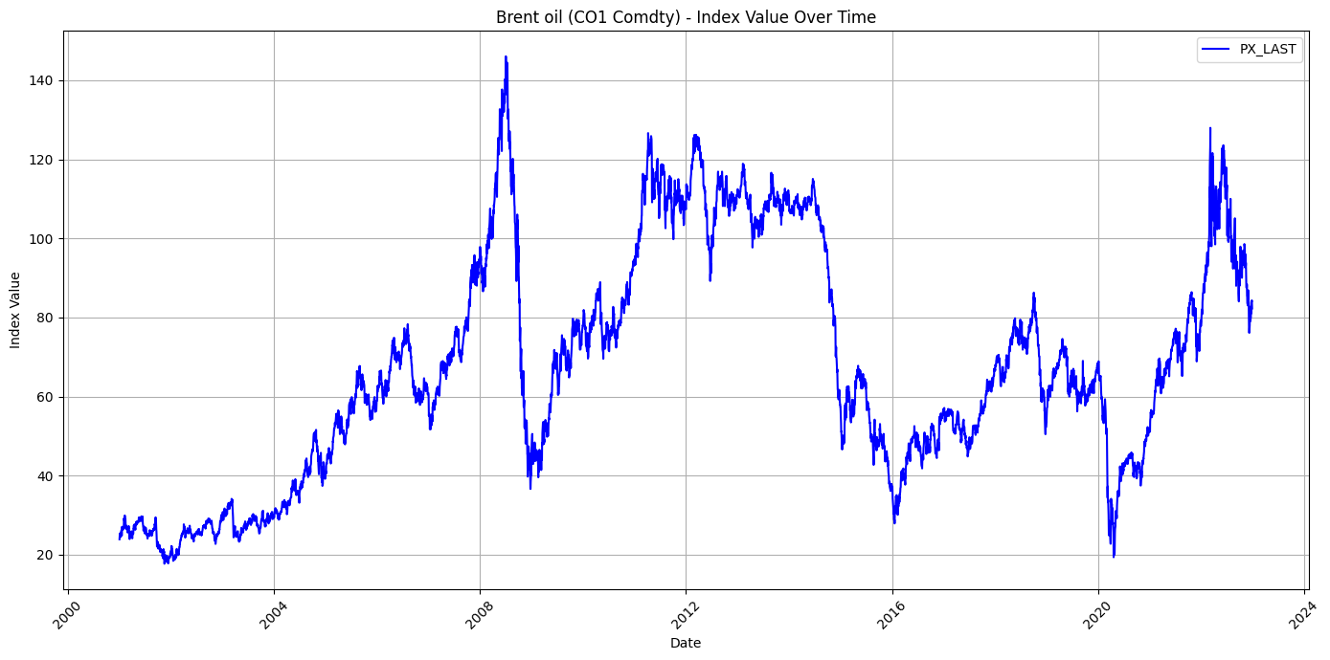

*Fig. 1. MSCI indices of different financial markets*

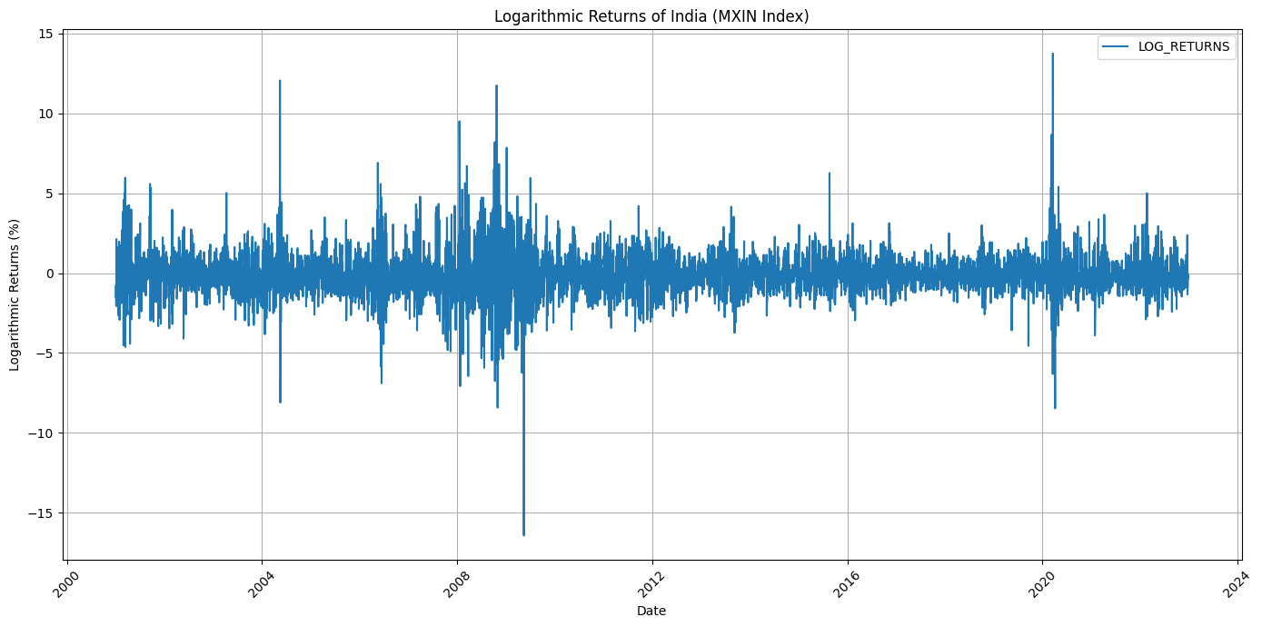

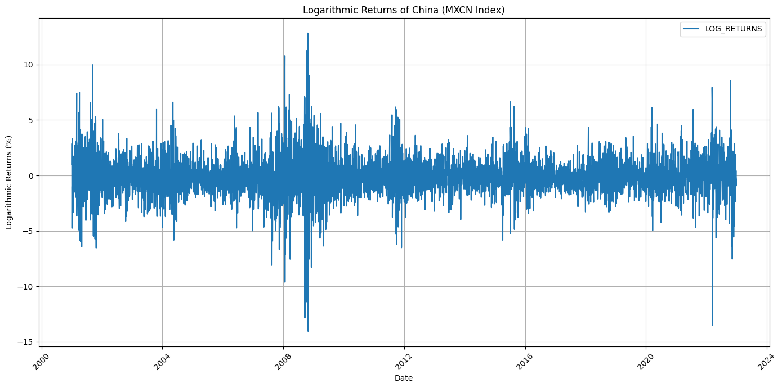

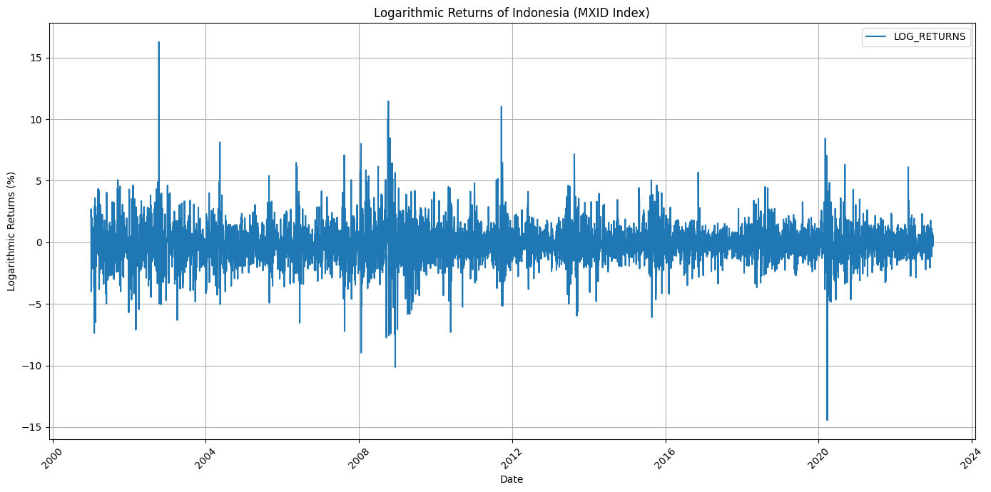

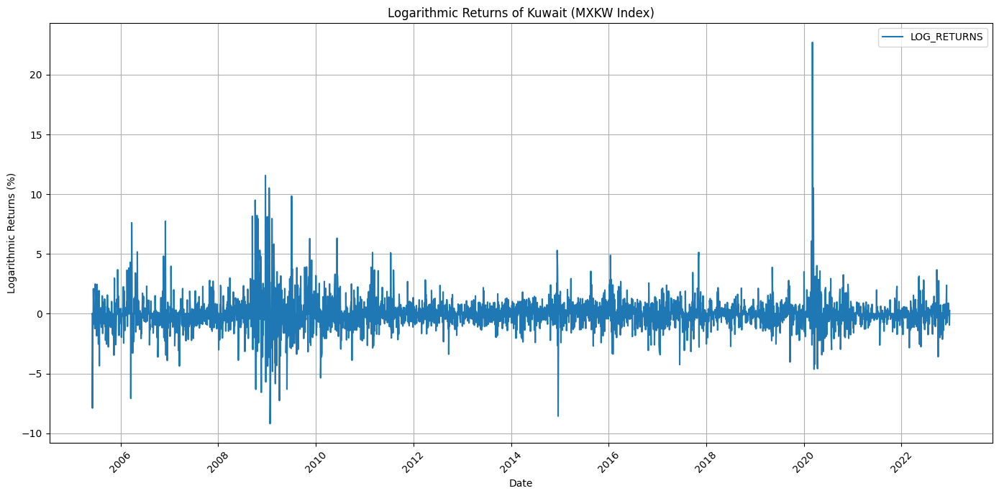

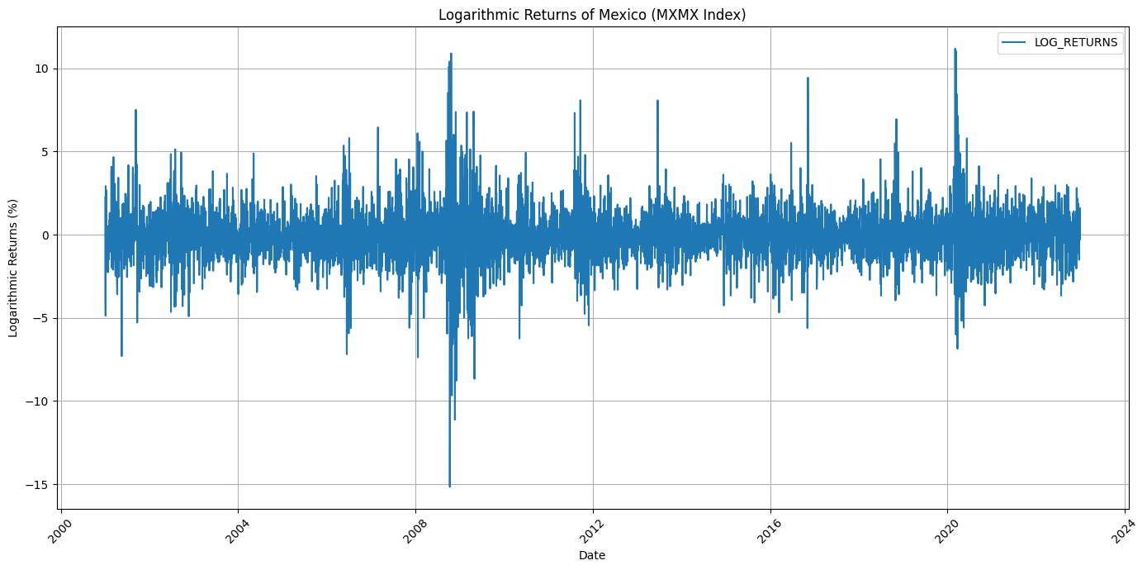

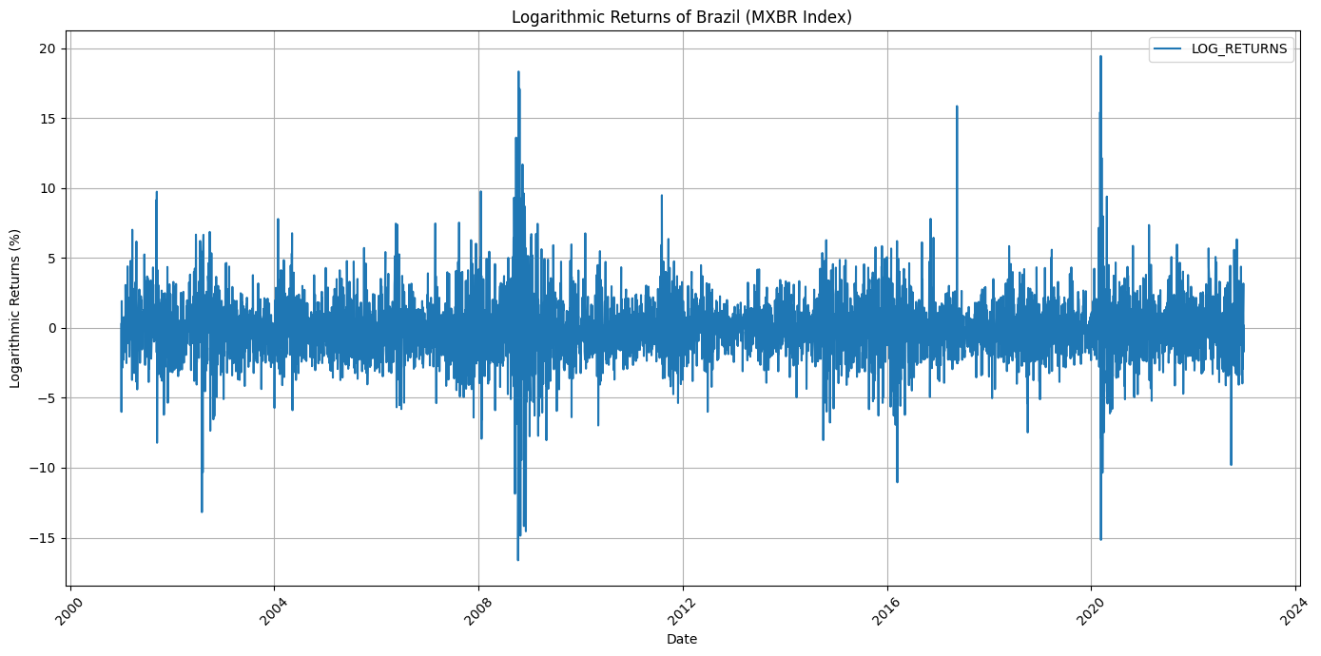

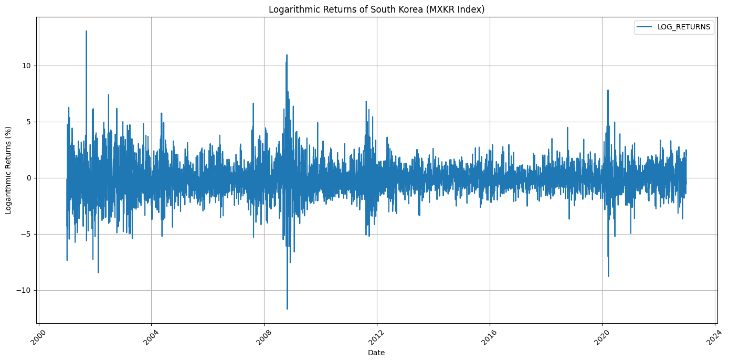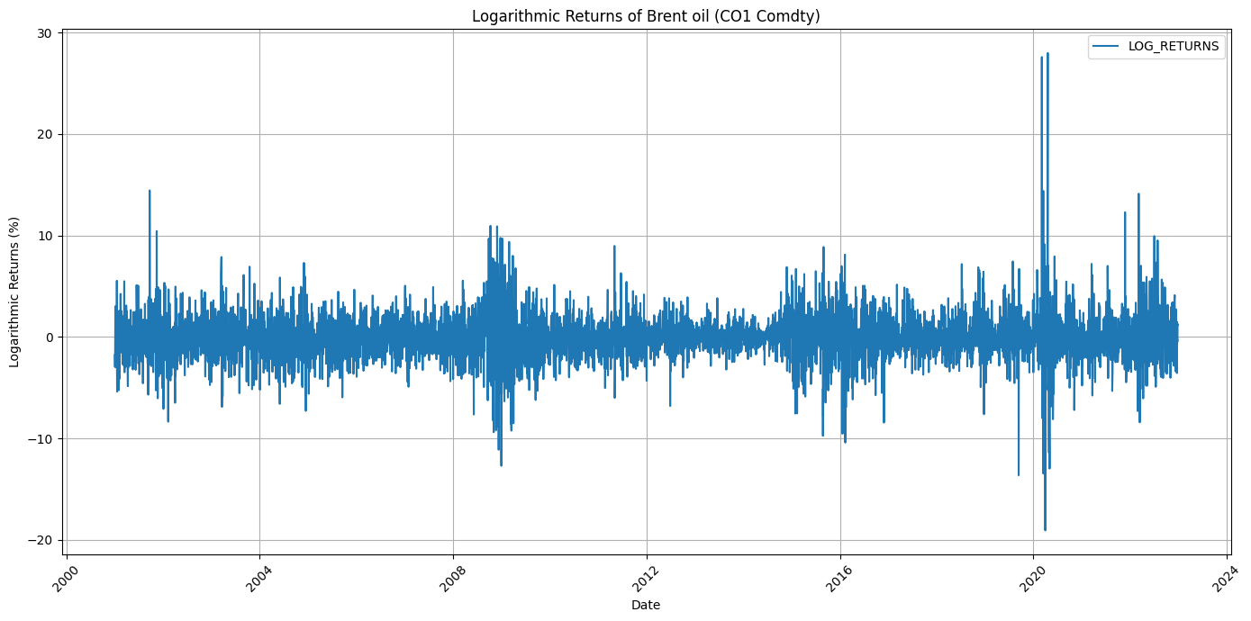

*Fig. 2. Returns of different financial markets*

*(From Top L to Bottom) India, China, Indonesia, Kuwait, Mexico, Brazil, South Korea, Brent Oil.*

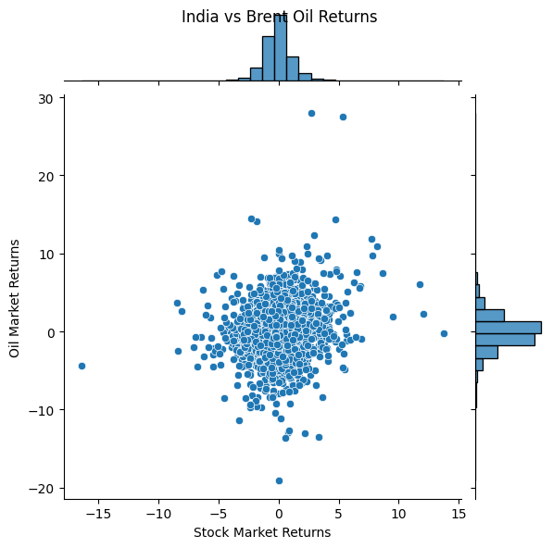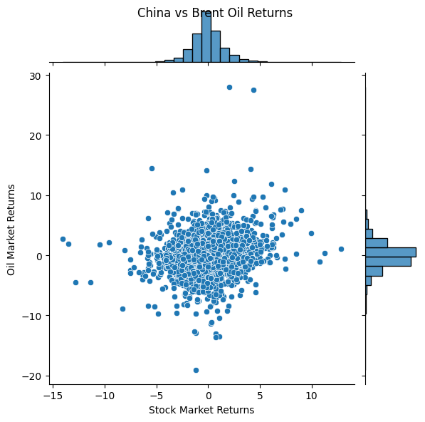

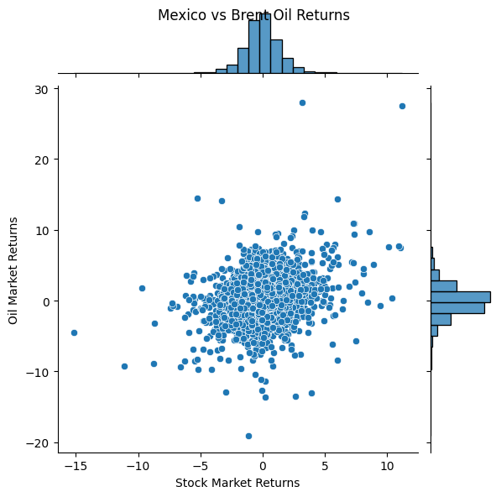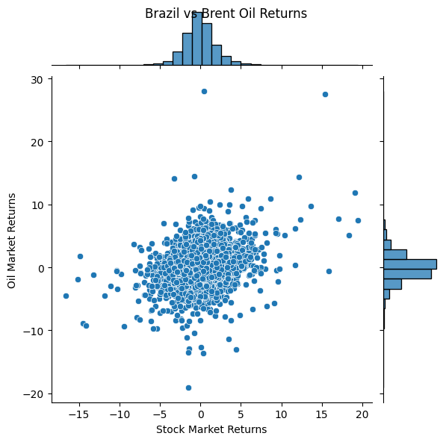

*Fig. 3. Scatter plots of returns between the oil market and the stock markets.*

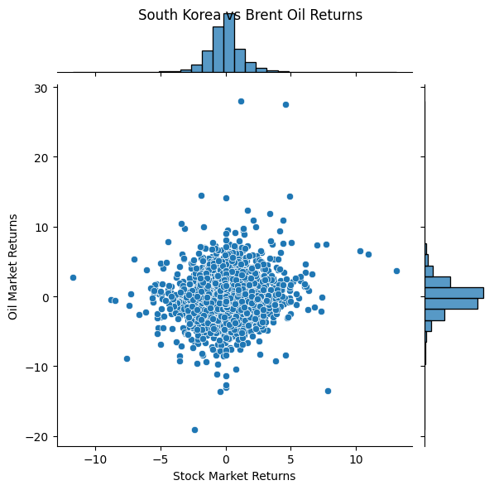

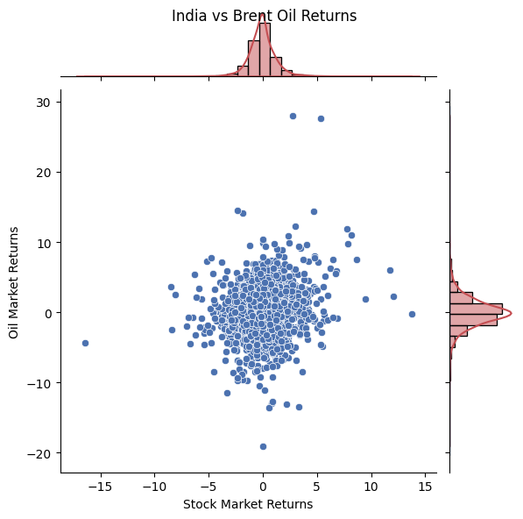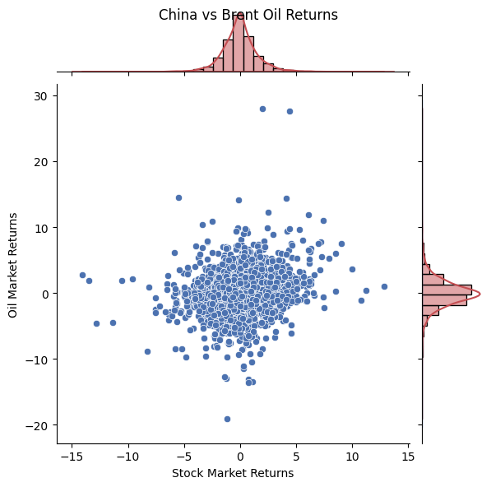

*Fig. 3. Scatter plots of returns between the oil market and the stock markets.*

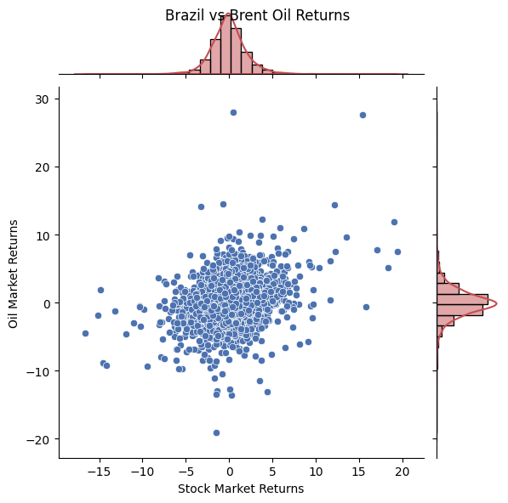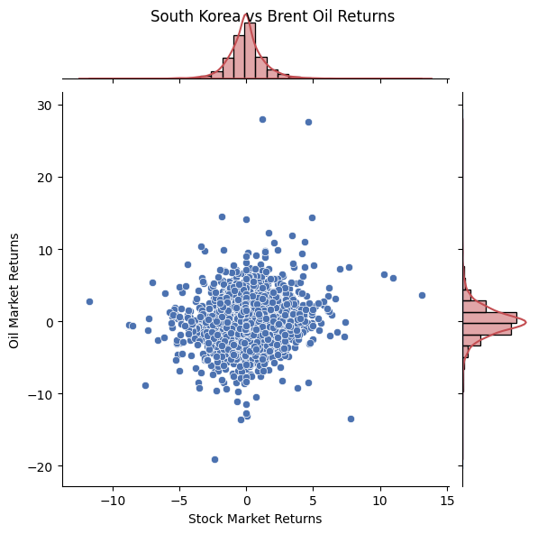

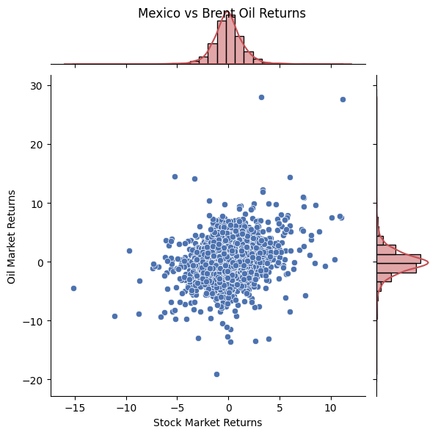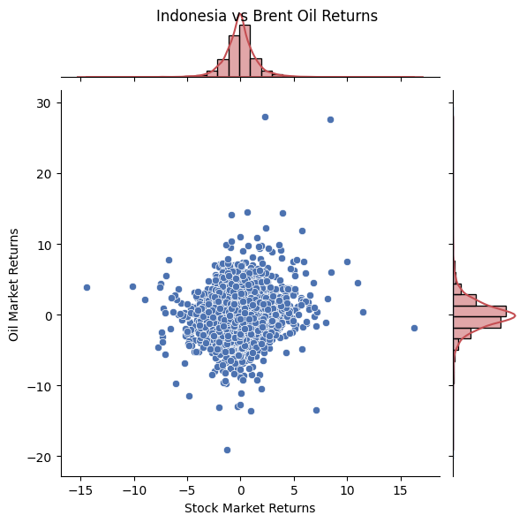

*Fig. 3. Scatter plots of returns between the oil market and the stock markets.*

*Table 3: Descriptive statistics of MSCI index returns of stock markets and oil market.*

|  | mean | max | min | median | std | skewness | kurtosis | q05 | q95 | jarque_bera | brent_corr | ljung_box | arch |
| --- | --- | --- | --- | --- | --- | --- | --- | --- | --- | --- | --- | --- | --- |
| India | -0.043 | 13.740 | -16.421 | -0.037 | 1.371 | 0.406 | 14.593 | -1.958 | 2.022 | (32292.832438699297, 0.0) | 0.155 | (102.53870667357401, 0.0) | (684.4374237140067, 0.0) |
| China | -0.018 | 12.838 | -14.059 | 0.000 | 1.686 | 0.033 | 9.491 | -2.486 | 2.676 | (10073.625219250529, 0.0) | 0.158 | (80.25228858689364, 0.0) | (1118.5683839252147, 0.0) |
| Brazil | -0.011 | 19.434 | -16.619 | -0.059 | 2.217 | 0.468 | 11.344 | -3.131 | 3.450 | (16854.551858621748, 0.0) | 0.305 | (68.44552102932323, 0.0) | (1470.3725793569363, 0.0) |
| South Korea | -0.029 | 13.091 | -11.722 | 0.000 | 1.424 | 0.279 | 9.455 | -2.118 | 2.283 | (10036.979160916595, 0.0) | 0.133 | (31.230140651633583, 0.052) | (813.6557424618001, 0.0) |
| Mexico | -0.023 | 11.183 | -15.159 | -0.051 | 1.586 | 0.282 | 9.778 | -2.341 | 2.391 | (11060.192585220986, 0.0) | 0.273 | (96.37611084851379, 0.0) | (1341.1080276692132, 0.0) |
| Indonesia | -0.049 | 16.261 | -14.444 | 0.000 | 1.565 | 0.304 | 10.775 | -2.354 | 2.393 | (14542.371776422493, 0.0) | 0.121 | (74.05872809103774, 0.0) | (468.8834420147517, 0.0) |
| Kuwait | -0.005 | 22.711 | -9.199 | 0.000 | 1.231 | 2.266 | 40.868 | -1.654 | 1.715 | (277929.1825517608, 0.0) | 0.086 | (138.27086081030123, 0.0) | (400.76853640040605, 0.0) |
| Brent oil | -0.022 | 27.976 | -19.077 | -0.070 | 2.305 | 0.633 | 14.534 | -3.421 | 3.585 | (32190.194970732507, 0.0) | 1.000 | (42.97754086819164, 0.002) | (564.7412183573323,  0.0) |

*5.2. Estimates and selections of the copulas*

In this subsection, we will select the optimal copula functions for the oil market paired with each stock market based on the standardized residuals (εit, εst), by employing the inference function for margins (IFM) method (Nelsen, 2006). According to the LLF values presented in

***CONCLUSION***

Estimating the downside and upside risk spillovers from the oil market to the stock markets and accordingly identifying the riskiest stock markets are essential for international capital holders and supervisory authorities. To accurately evaluate the downside risk spillovers, Tian and Ji (2022) propose the GARCH CQR model that can describe the nonlinearity of the downside tail dependence structure between financial variables. As is known, measuring the upside risk and its spillovers is also critical especially for global investors with short positions of the

stock markets.

In response to the problem that the model in Tian and Ji (2022) cannot capture the nonlinearity of the upside tail dependence between financial variables, this study constructs a GARCH CQR-based UCoVaR model to calculate upside CoVaR and risk spillovers. In the empirical study, based on the MSCI daily data from January 2000 to June 2021, we assess the risk contribution of Brent crude oil to stock markets in six important countries, using the GARCH CQR-based DCoVaR and UCoVaR models. The empirical results reveal that oil displays the largest downside and upside risk spillovers on the Indian and Chinese stock markets.

And the Brazilian and Mexican that the downside and upside risk spillovers show the asymmetric feature, with upside risk spillovers less than downside risk spillovers, which is consistent with the phenomenon of flight-to-quality. Moreover, the dynamic risk spillover effects show heterogeneity over time and are comparatively different for each country.

Finally, based on these findings, we provide important implications for international capital

holders and supervisory authorities optimizing the investment portfolios and formulating supervision policy.